**Ancient Egypt 30.4**

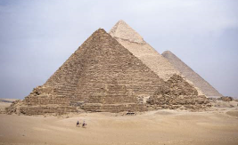

Log on to the following website:

<https://www.bbc.co.uk/bitesize/articles/zbp6t39>

**Watch the videos…**

**Activity**

**Ancient Egyptian life**

**Create a poster about ancient Egyptian life.**

You could include jobs, houses, food or anything from your own knowledge about ancient Egypt.

**Look at the posters below. Use these to inspire you to create your own.**

