Year 3 Maths:
Hello Everyone,
I hope that you are all well and keeping safe. This week is going to be Multiplying and Dividing using different Times Tables.
- Please click on this link: https://whiterosemaths.com/homelearning/year-3/

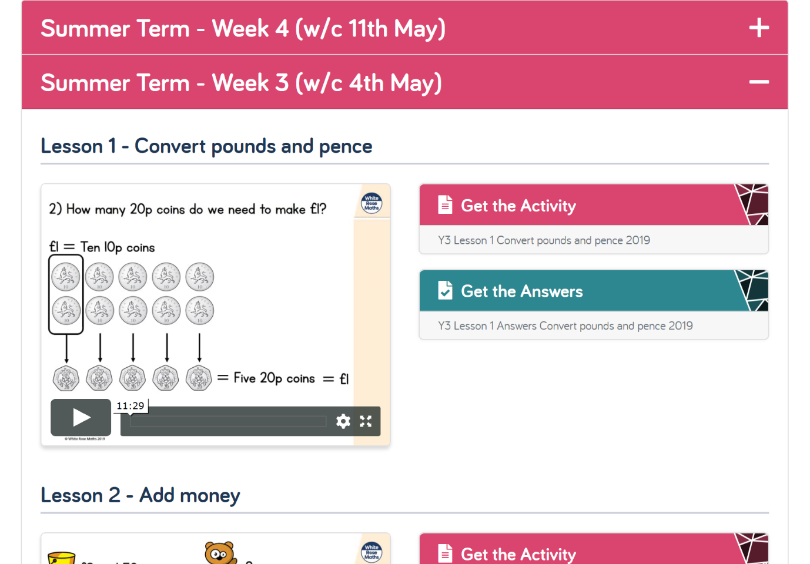
- You will come to a page that looks like this:

- Please click on Summer Term – Week 4 (w/c 11th May)

- Please complete Lesson 1 and 2 (see below). Remember you have Monday and Tuesday to do this so take your time.

- Please watch the video on the left to help with your knowledge and then press ‘Get the Activity.’

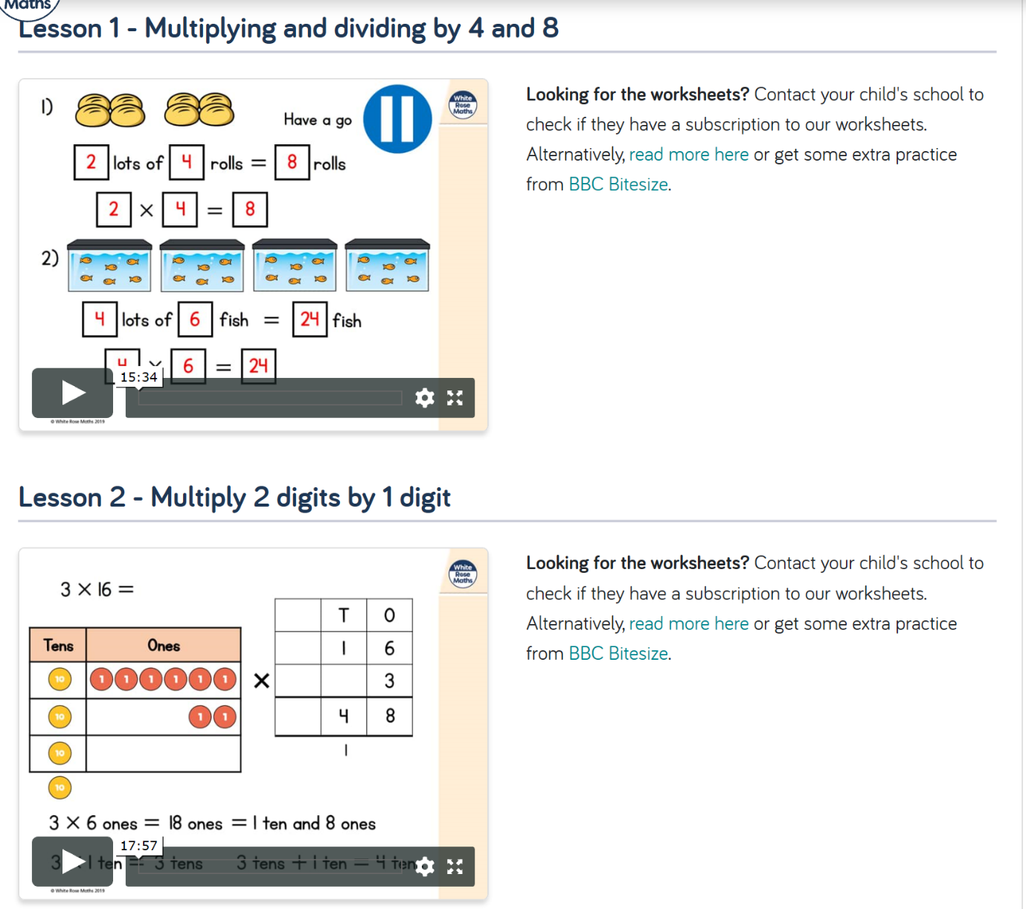
- There is a video on the ‘Foxes Class Page’ showing how to answer the questions online if you are not able to print it.

- Otherwise, you are more than welcome to answer the questions on scrap paper using the worksheet on the screen.

