Year 3 Maths:
Hello Everyone,
I hope that you are all well and keeping safe. This week is going to be Multiplying and Dividing using different Times Tables. In the first two lessons, you looked at multiplication. Now you are going to look at Division.
- Please click on this link: https://whiterosemaths.com/homelearning/year-3/

- Please scroll down to Lesson 3 and 4. Watch the videos and follow the videos to help with your understanding of division.

- As seen in Lesson 1 and 2, there were no worksheets to go through.

- Have a go at the questions below to test your knowledge of Multiplication:

Questions on Multiplication:
1.

There are _______ lots of ________ flowers.

Number Sentence: ________ x _________ =

2.

There are _____________ lots of ___________ flowers.

Number Sentence: ______________ x ____________ =

3. Array:
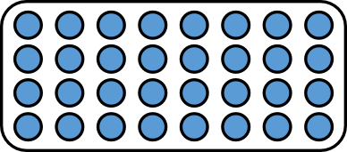

Rows: _______________

Columns: ______________

Number Sentence: _________ x ____________ =

4. Array:

Rows: _____________

Columns: ______________

Number Sentence: _______________ x ______________ =

5. Multiplication Questions:

