Year 4 Maths: Lesson 1 and 2.
Hello Everyone,
I hope that you are all well and keeping safe. We have done a lot of Fractions recently, so we are going to recap some of the previous topics. This week is going to be Multiplying and Dividing using problem solving and finding the perimeter of rectangles.

- Please click on this link: https://whiterosemaths.com/homelearning/year-4/

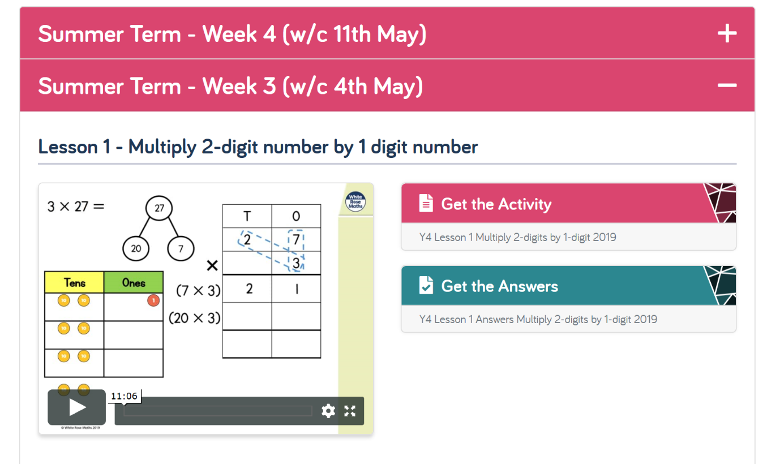
- You will come to a page that looks like this:

- Please click on Summer Term – Week 4 (w/c 11th May)

- Please complete Lesson 1 and 2 (see below). Remember you have Monday and Tuesday to do this so take your time.

- Please watch the video on the left to help with your knowledge and then press ‘Get the Activity.’

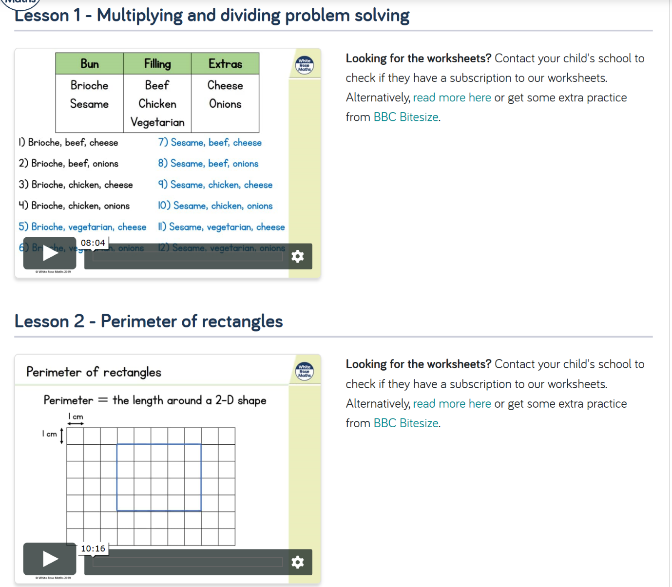
- There is a video on the ‘Foxes Class Page’ showing how to answer the questions online if you are not able to print it.

- Otherwise, you are more than welcome to answer the questions on scrap paper using the worksheet on the screen.

