Year 4 Maths: Lesson 3 and 4
Hello Everyone,
I hope that you are all well and keeping safe.
- Please click on this link: https://whiterosemaths.com/homelearning/year-4/

- Please scroll down to Lesson 3 and 4. Remember you have Wednesday and Thursday to do this so take your time. Use the BBC Bitesize link to get some more questions.

- Please take your time to work through the video and work through the questions they give you.

- As on Lesson 1 and 2 this week, there are no additional worksheets. Please look at the questions below that will test you on your knowledge of Lesson 1 and 2.

1. There are 4 children. They are each allowed a chocolate bar and a donut, but they cannot have the same combination.
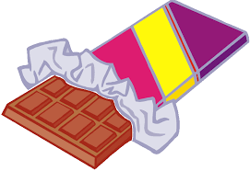

Above are the chocolate bars and the donuts that are available. What different combinations can you make for each child?

1.
2.
3.
4.

2. There are 6 children waiting in line for an ice cream. Look at the menu below.
Flavour of Ice Cream  Chocolate  Vanilla  Mint Choc Chip | Sauce  Caramel  Strawberry  Chocolate | Fruit  Raspberries  Apple  Banana

Each child needs a different combination of ice cream, sauce and fruit.
Can you find some of the combinations?

1.
2.
3.
4.
5.
6.

3. Find the Perimeter of this Rectangle:
(Remember the Units)

4. Find the Perimeter of this Rectangle:
(Remember the Units)

m

m

