Maths Year 4 – Dividing a 4-digit number by a 1-digit number.
Please follow the link - https://www.bbc.co.uk/bitesize/articles/zmcpscw
Work your way through the ‘Learn’ section and move onto the ‘Practise’ section.
- Activity 1 – A game to play with your parents.
- Activity 2 – If you do not have a dice, go online and type in ‘dice roller’ and it will come up with some links that roll a dice for you (https://www.random.org/dice/?num=1). The board game is below for you.
- Activity 3 – There is no activity 3 on BBC but I have set some division questions using the bus stop method below.

Activity 2:
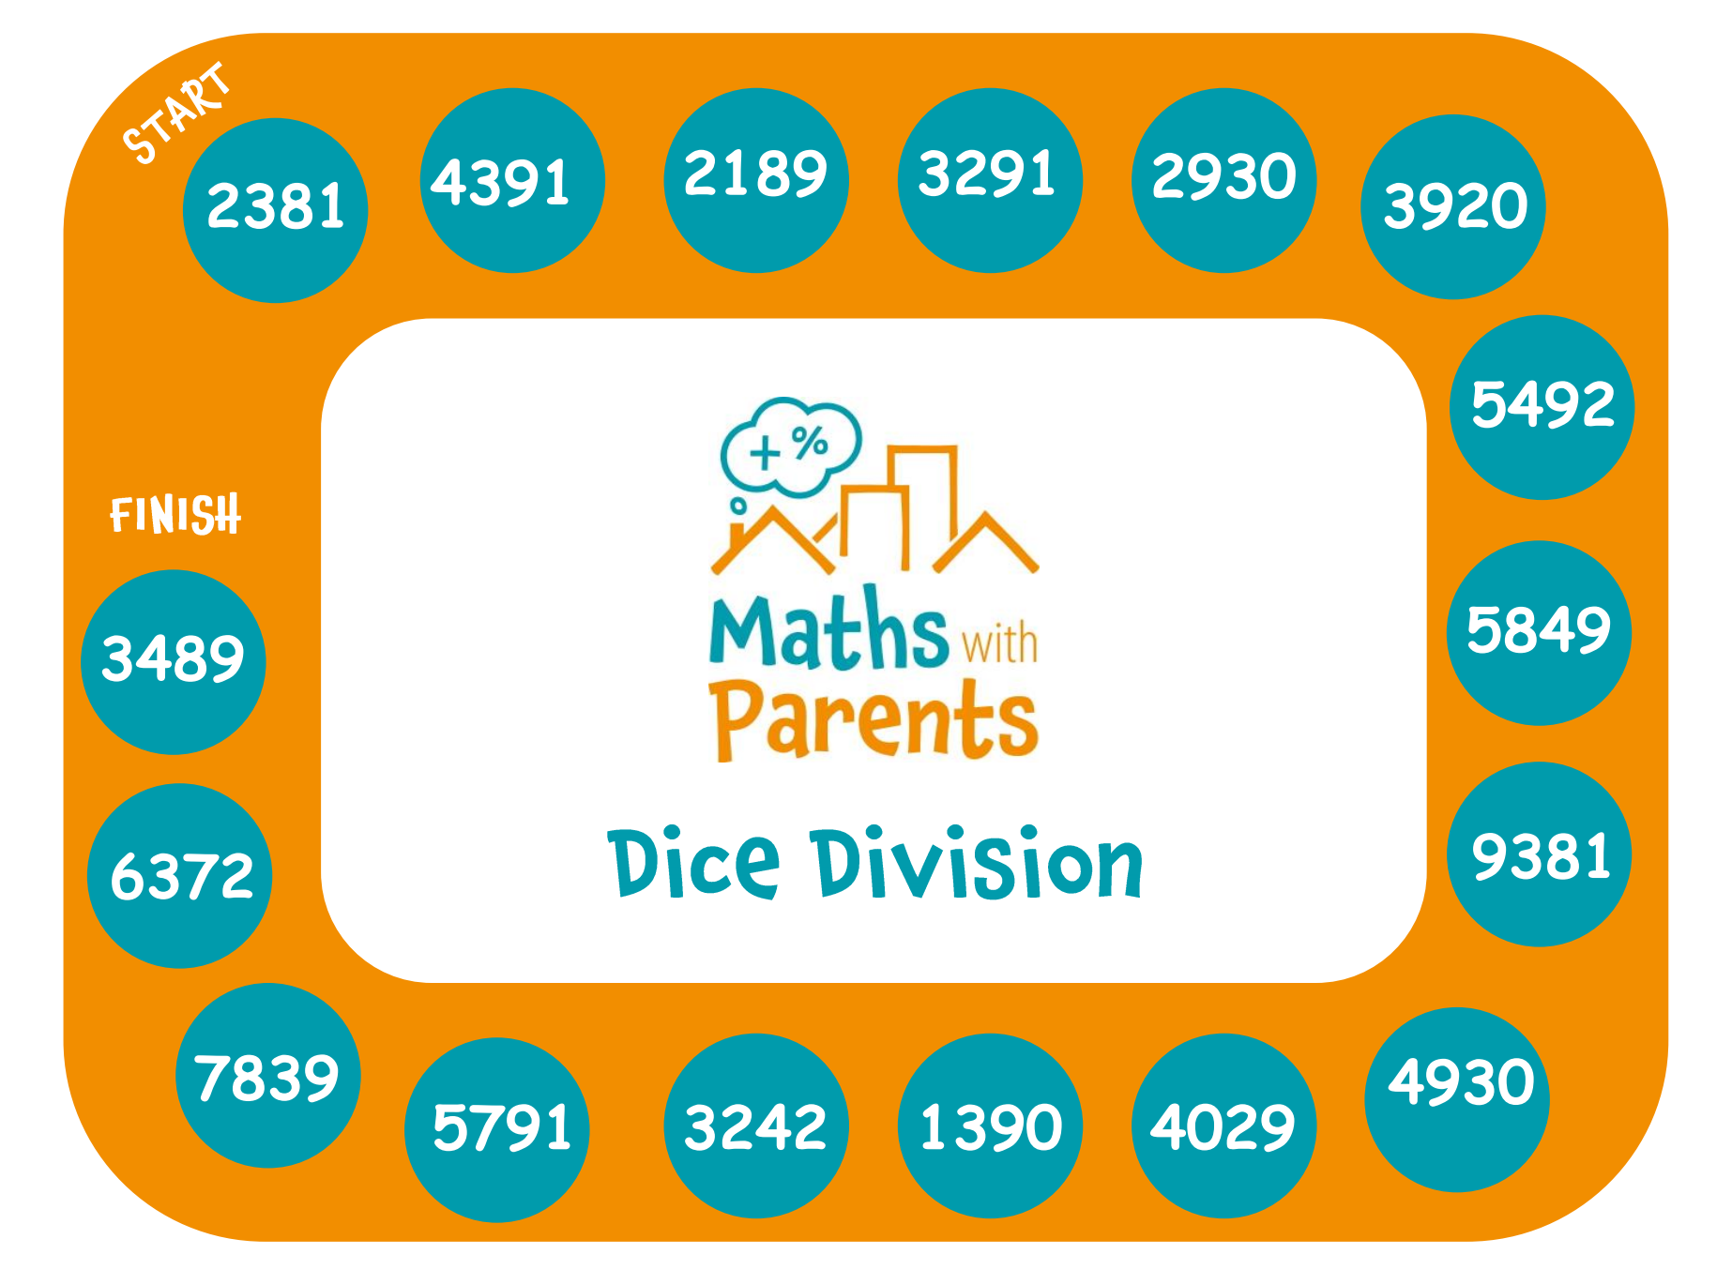

Activity 3:
