Year 4 Maths: Lesson 1 (Multiplying)
Hello Everyone,
I hope that you are all well and keeping safe. We have done a lot of Fractions recently, so we are going to recap some of the previous topics. This week is going to be Multiplying.
- Please click on this link: https://whiterosemaths.com/homelearning/year-4/

- You will come to a page that looks like this:
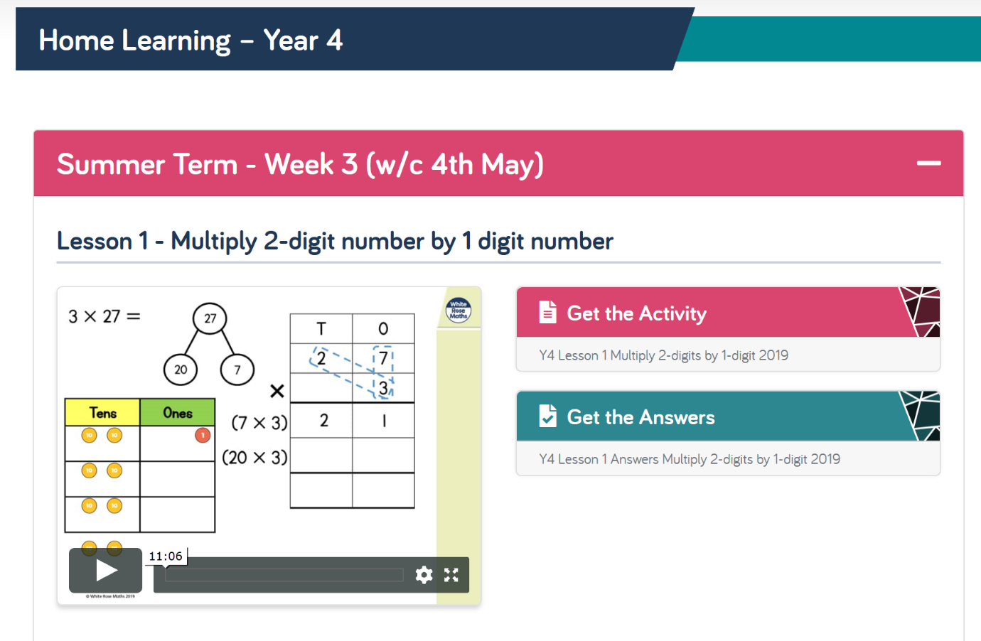

- Please watch the video on the left to help with your knowledge and then press ‘Get the Activity.’

- Please complete Lesson 1 and 2. Remember you have Monday and Tuesday to do this so take your time.

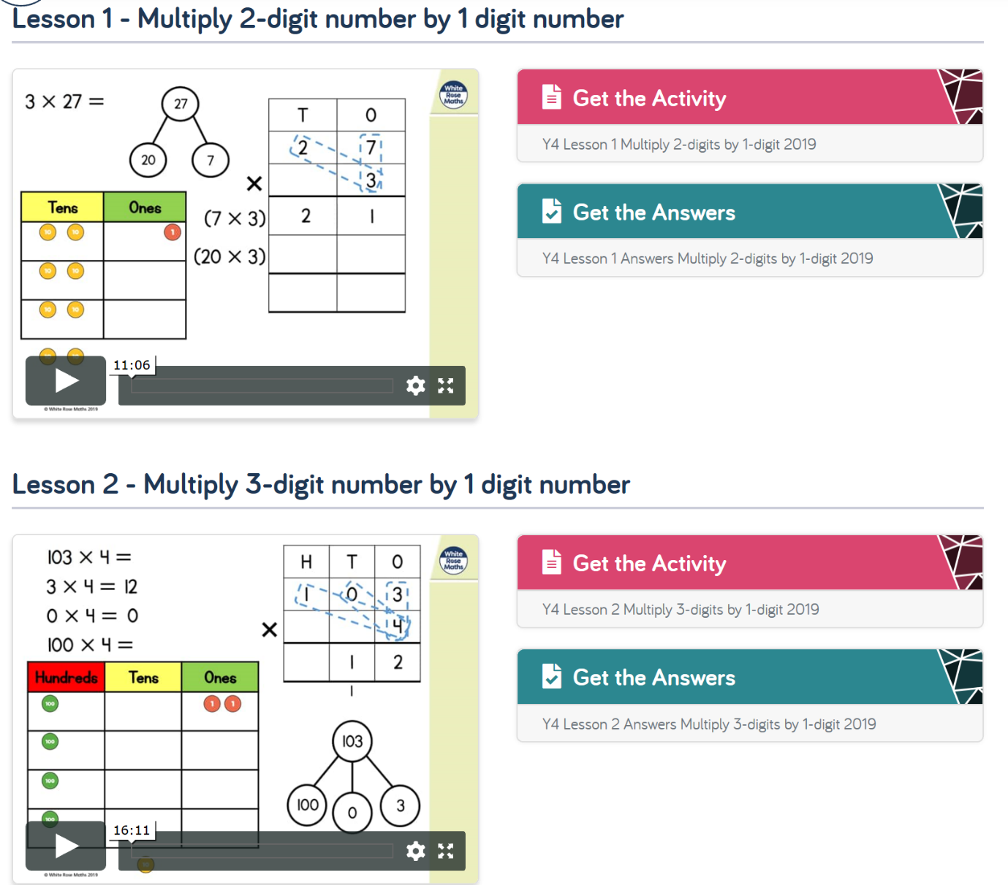
- There is a video on the ‘Foxes Class Page’ showing how to answer the questions online if you are not able to print it.

- Otherwise, you are more than welcome to answer the questions on scrap paper using the worksheet on the screen.

