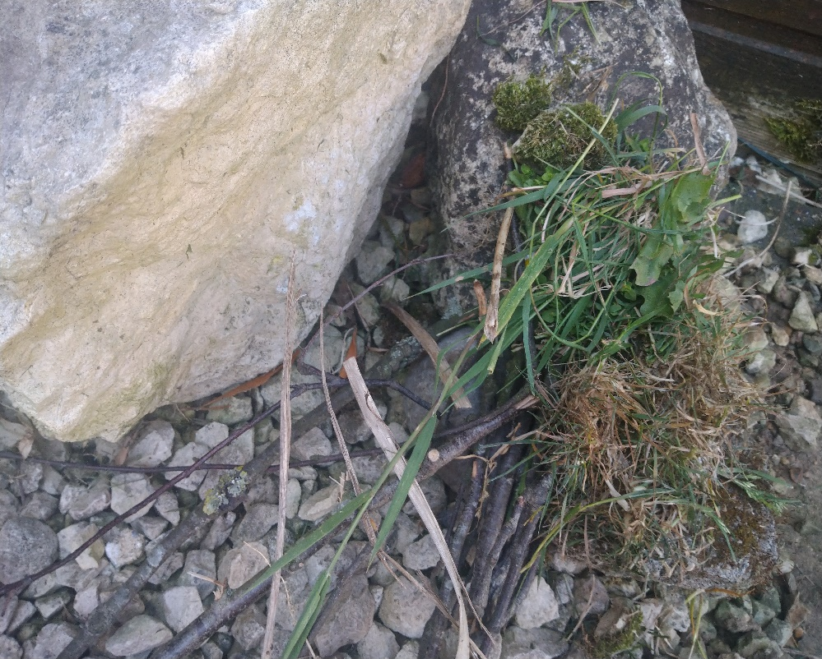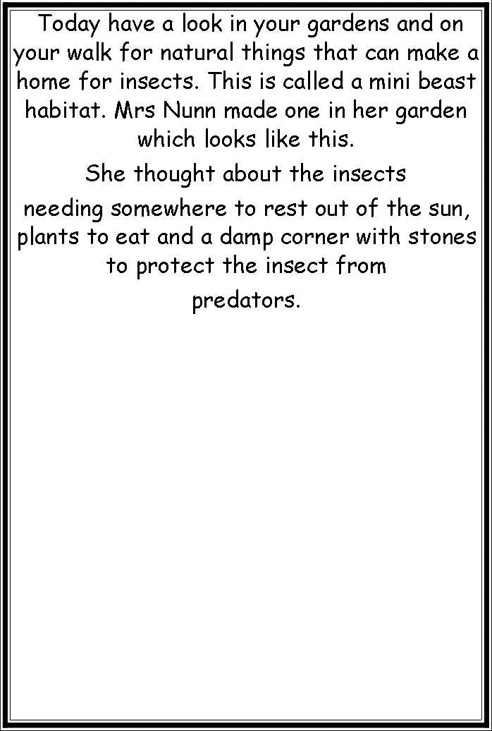

**Rabbits Home learning 22/5/20**

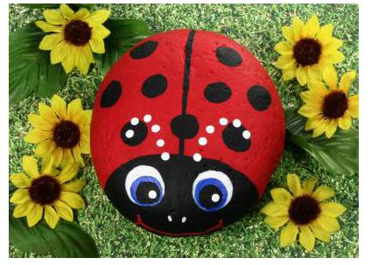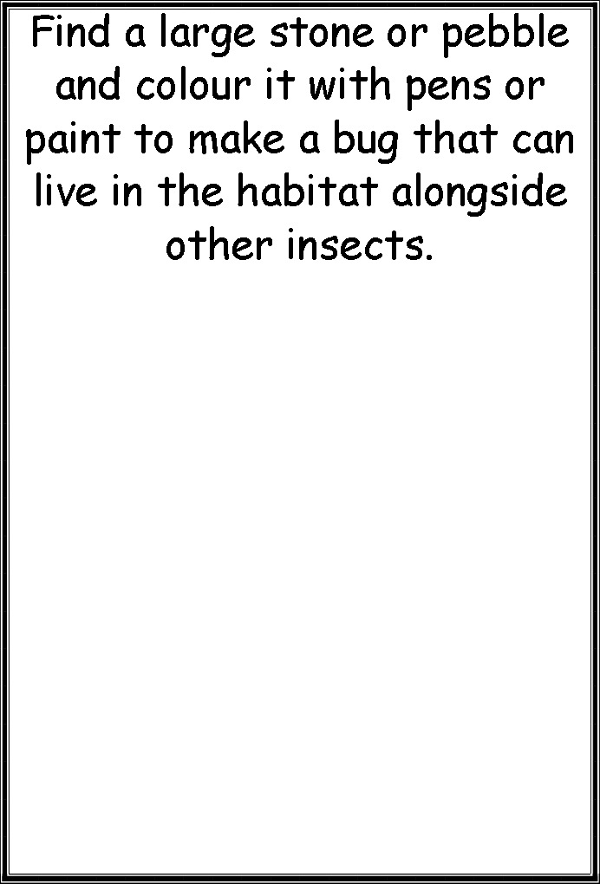

Enjoy next week, it’s officially half term.

Look after yourselves and your families. Be sensible and stay safe.

Mrs Golden and Mrs Nunn