Religious Education
LQ: What happened at Pentecost?
Read the story of Pentecost with your adult: (Pentecost Acts 2: 1-15,22 and 37-41)

The Holy Spirit Comes at Pentecost

When the day of Pentecost came, they were all together in one place. ² Suddenly a sound like the blowing of a violent wind came from heaven and filled the whole house where they were sitting. ³ They saw what seemed to be tongues of fire that separated and came to rest on each of them. ⁴ All of them were filled with the Holy Spirit and began to speak in other tongues^{[a]} as the Spirit enabled them.
⁵ Now there were staying in Jerusalem, God-fearing Jews from every nation under heaven. ⁶ When they heard this sound, a crowd came together in bewilderment, because each one heard their own language being spoken. ⁷ Utterly amazed, they asked: “Aren’t all these who are speaking Galileans? ⁸ Then how is it that each of us hears them in our native language? ⁹ Parthians, Medes and Elamites; residents of Mesopotamia, Judea and Cappadocia, Pontus and Asia,^{[b]} ¹⁰ Phrygia and Pamphylia, Egypt and the parts of Libya near Cyrene; visitors from Rome ¹¹ (both Jews and converts to Judaism); Cretans and Arabs—we hear them declaring the wonders of God in our own tongues!” ¹² Amazed and perplexed, they asked one another, “What does this mean?”
¹³ Some, however, made fun of them and said, “They have had too much wine.”

Peter Addresses the Crowd
¹⁴ Then Peter stood up with the Eleven, raised his voice and addressed the crowd: “Fellow Jews and all of you who live in Jerusalem, let me explain this to you; listen carefully to what I say.
²² “Fellow Israelites, listen to this: Jesus of Nazareth was a man accredited by God to you by miracles, wonders and signs, which God did among you through him, as you yourselves know.
³⁷ When the people heard this, they were cut to the heart and said to Peter and the other apostles, “Brothers, what shall we do?”
³⁸ Peter replied, “Repent and be baptized, every one of you, in the name of Jesus Christ for the forgiveness of your sins. And you will receive the gift of the Holy Spirit. ³⁹ The promise is for you and your children and for all who are far off—for all whom the Lord our God will call.”
⁴⁰ With many other words he warned them; and he pleaded with them, “Save yourselves from this corrupt generation.” ⁴¹ Those who accepted his message were baptized, and about three thousand were added to their number that day.
^{Question Time!}
Why is the spirit like a wind? Like a flame?
Why do they look drunk?
Why did people who listened come from 15 different countries?

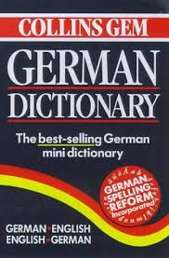
After reading the story and answering the questions, look at the different objects below:
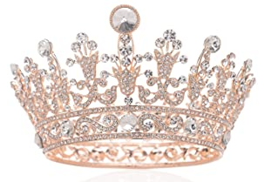

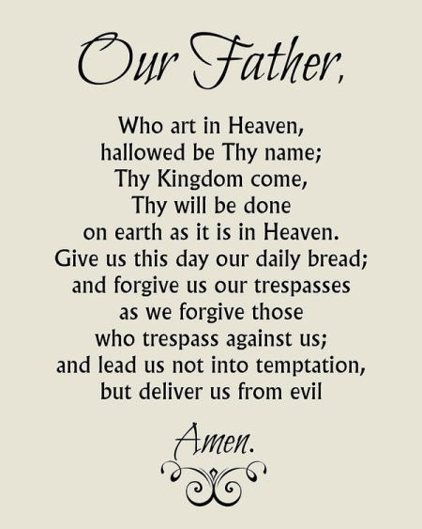
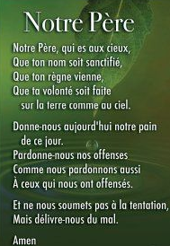

^{Question Time!}
How are all these things linked?
What story might they tell?
What do the different things stand for?

Activity: You have a choice of what activity you would like to do
a) Retell the story in their own words as if they were there.
b) Write a letter home to someone else to explain what you saw and what you felt. Have you converted to Christianity? What will you do now?
c) Retell the story through art and write a paragraph to explain what you have created.

