RE:
LQ: What symbols are used for the Holy Spirit during Pentecost
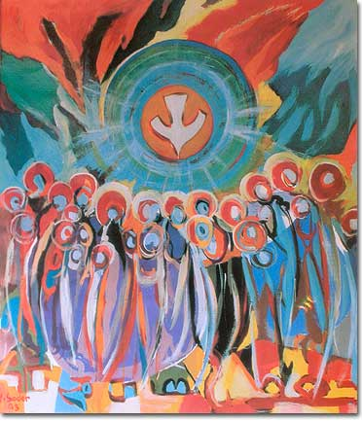
Activity 1: Look at the pictures below and for each picture, discuss the questions underneath.
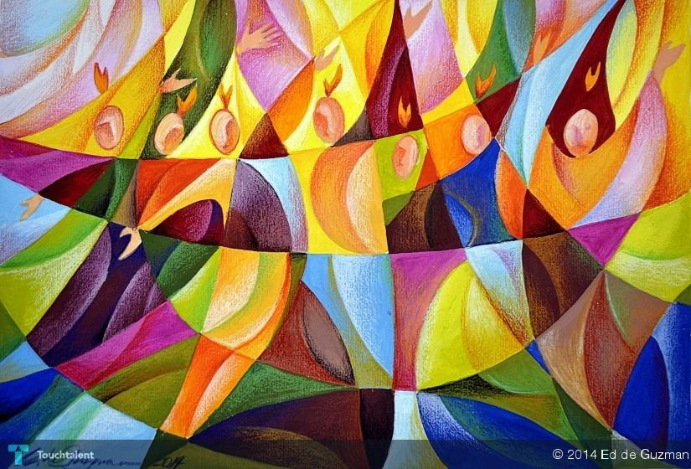
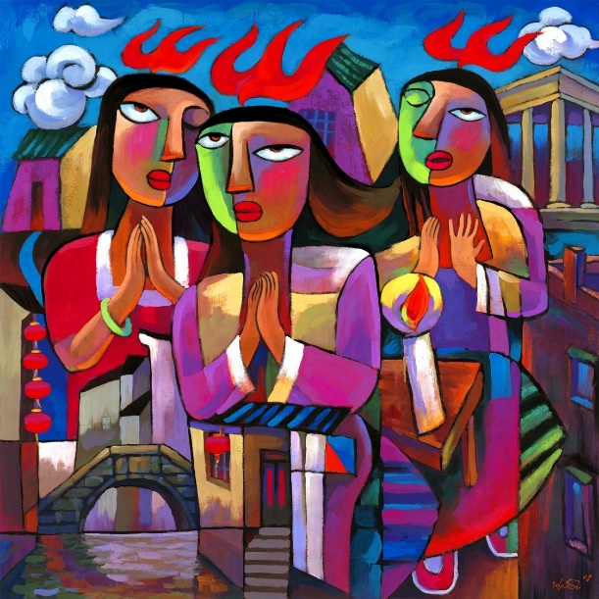
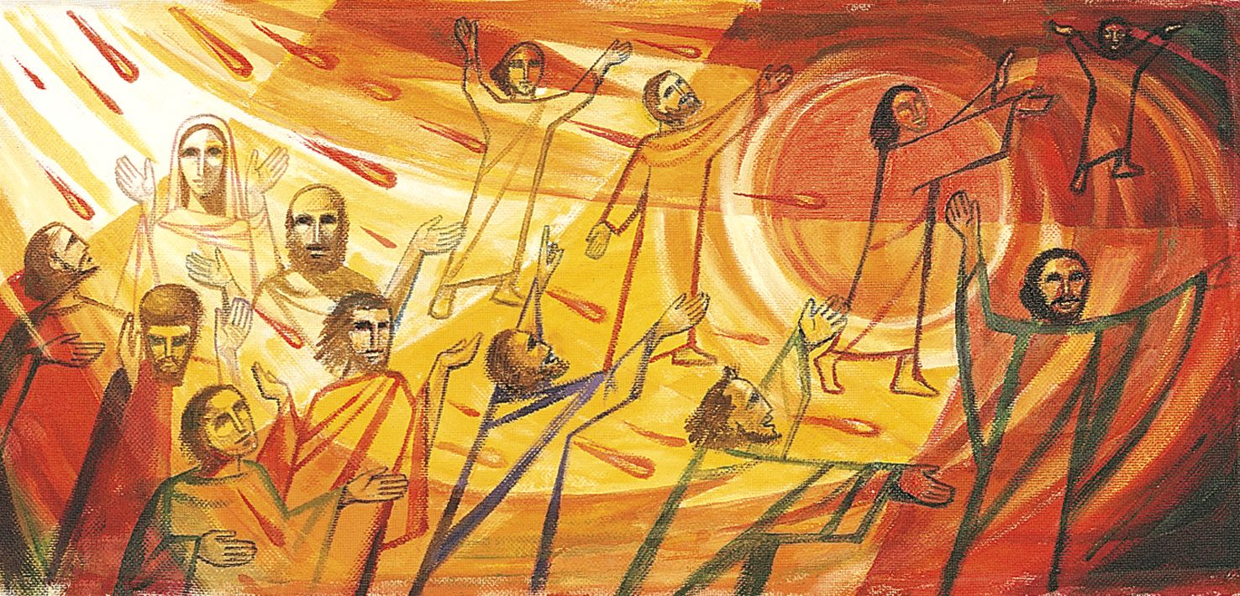
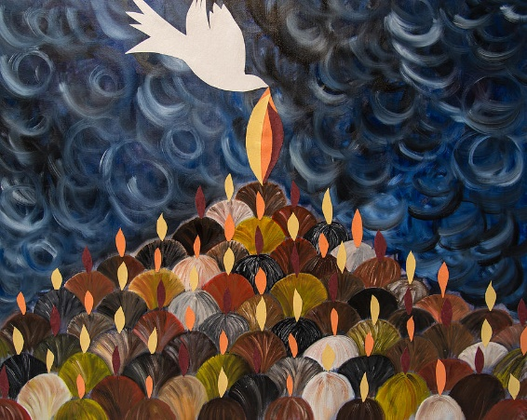

Questions:
- Which parts of the story have been emphasised? Why?
- Which parts of the story have been missed out? Why?
- Study the motions of the people in the artwork. Why might they feel like that? Which parts of the story has the artist had to portray symbolically?

Activity 2: ‘What is the Holy Spirit?’
Talk to your adult about what you know to be the ‘Holy Spirit.’
Watch this video: https://www.youtube.com/watch?v=oNNZO9i1Gjc

Now look at the PowerPoint labelled ‘Symbols of the Holy Spirit.’

- Can you link the symbols to the story?

Written Work: Choose two symbols for the ‘Holy Spirit’ and record underneath as a paragraph or bullet points why it represents the ‘Holy Spirit.’

