**Religious Education:**

Discuss these questions with your adult:

1. Why do you think Christians think the Holy Spirit is important now?
2. How could you describe the Holy Spirit (Draw a picture to represent it)



You could describe the Holy Spirit as a ‘Battery.’

Christians can’t work and live Gods way without the Holy Spirits power.

1. Now watch this video: <http://request.org.uk/life/beliefs/christianity-basically-the-holy-spirit/>

* Have your ideas changed?
* Why is the Holy Spirit important to Christians?
* What are the jobs for the Holy Spirits? – Create a list of jobs that the Holy Spirit has.

1. Look at the 7 gifts given by the Holy Spirit – If these gifts are given and used, then there will be 9 ‘fruits’ or benefits for humans.

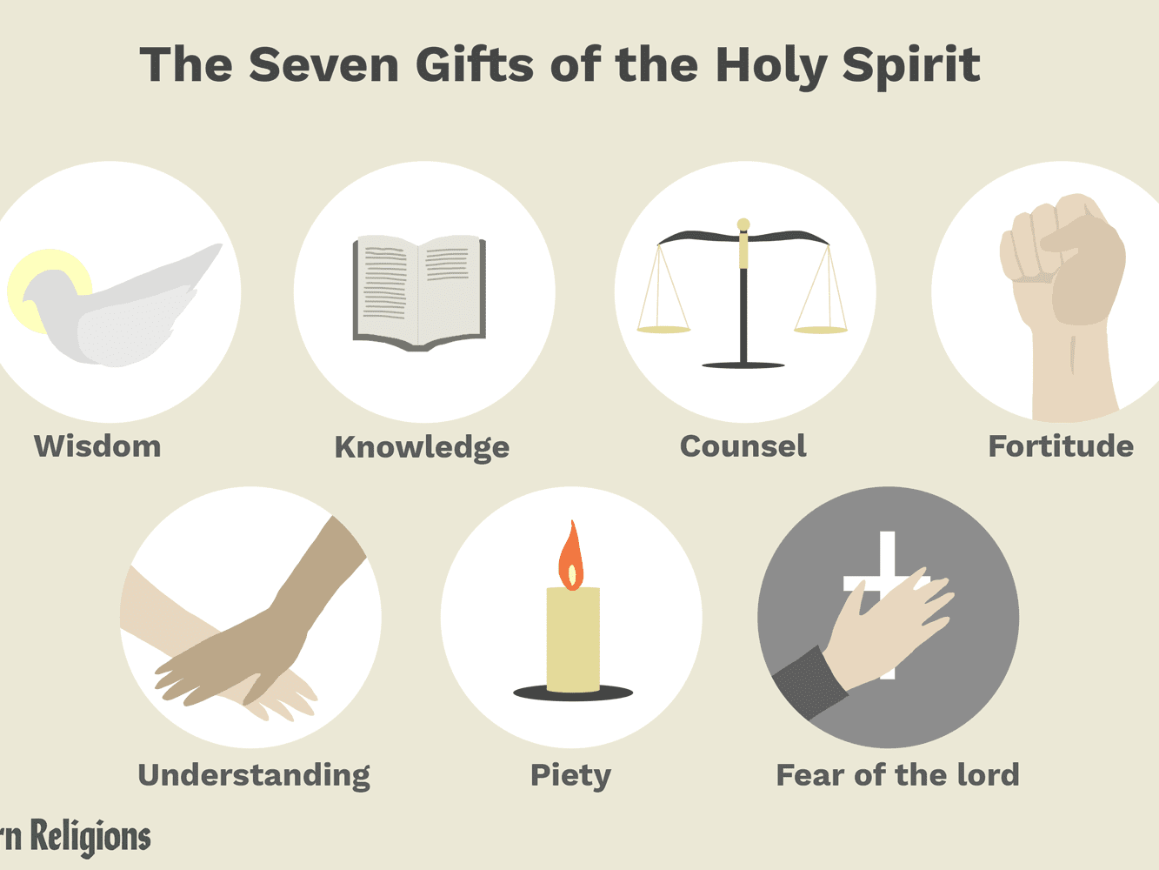

1. Look at the PowerPoint named ‘RE Fruits of the Holy Spirit’ on the 9 fruits that will be given to humans.

**Activity:**

Once you have looked at the fruits of the Holy Spirit and the 7 gifts that the Holy Spirit gives, think back to the symbols of the Holy Spirit.

Write an acrostic poem about the Holy Spirit that shares the Holy Spirits Characteristics and expresses their ideas.

H

O

Use the ideas you have learnt about to fill in these letters to make a nice acrostic poem.

L

Y

S

P

I

R

I

T

Or

Pick three Symbols of the Holy Spirit found on the PowerPoint named ‘Symbols of the Holy Spirit.’

* Draw the symbols and decorate them in any way you would like.