How do Christians use art in worship?
Look at the following pictures depicting examples of religious art. Pick your favourite and answer the questions.
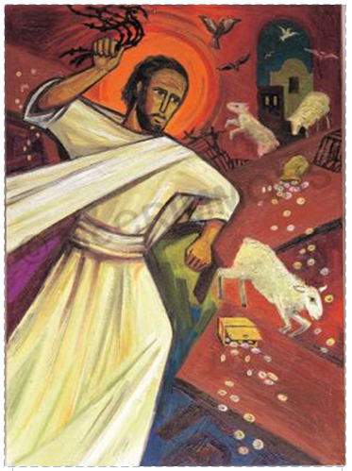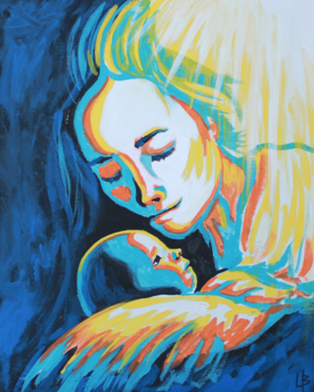
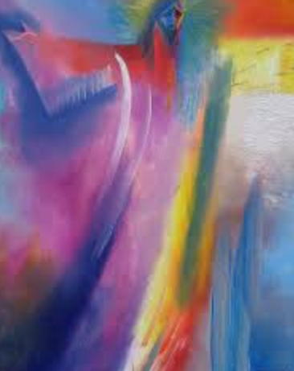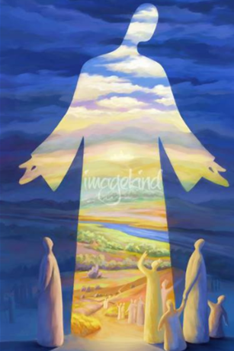
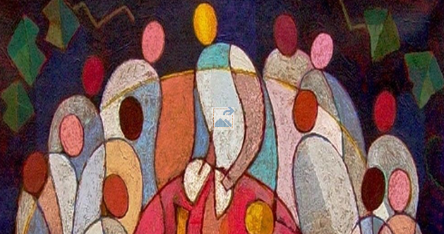
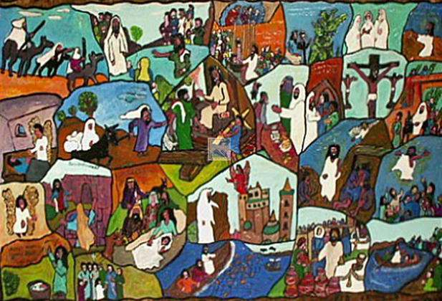

Now answer these questions:
- What title would you give this picture?
- What do you like about the picture?
- What don’t you like about the picture?
- How does this picture make you feel?
- How does the picture show worship and remembering Jesus?
- What questions do you have for the person/people in the picture?
- What questions would you ask the artist?

