RE Week 4
Look carefully at these cathedrals…
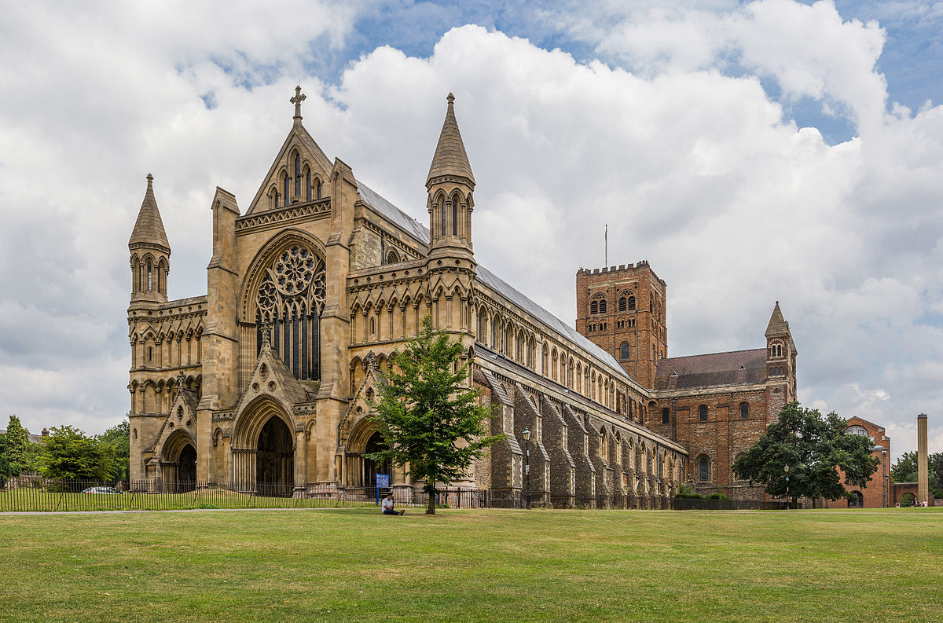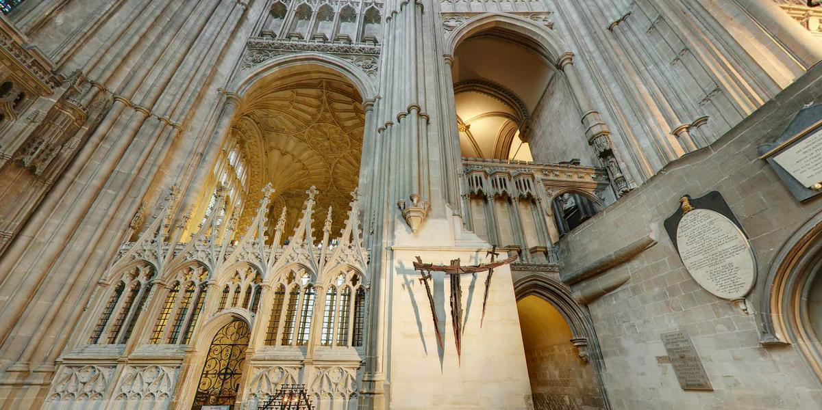

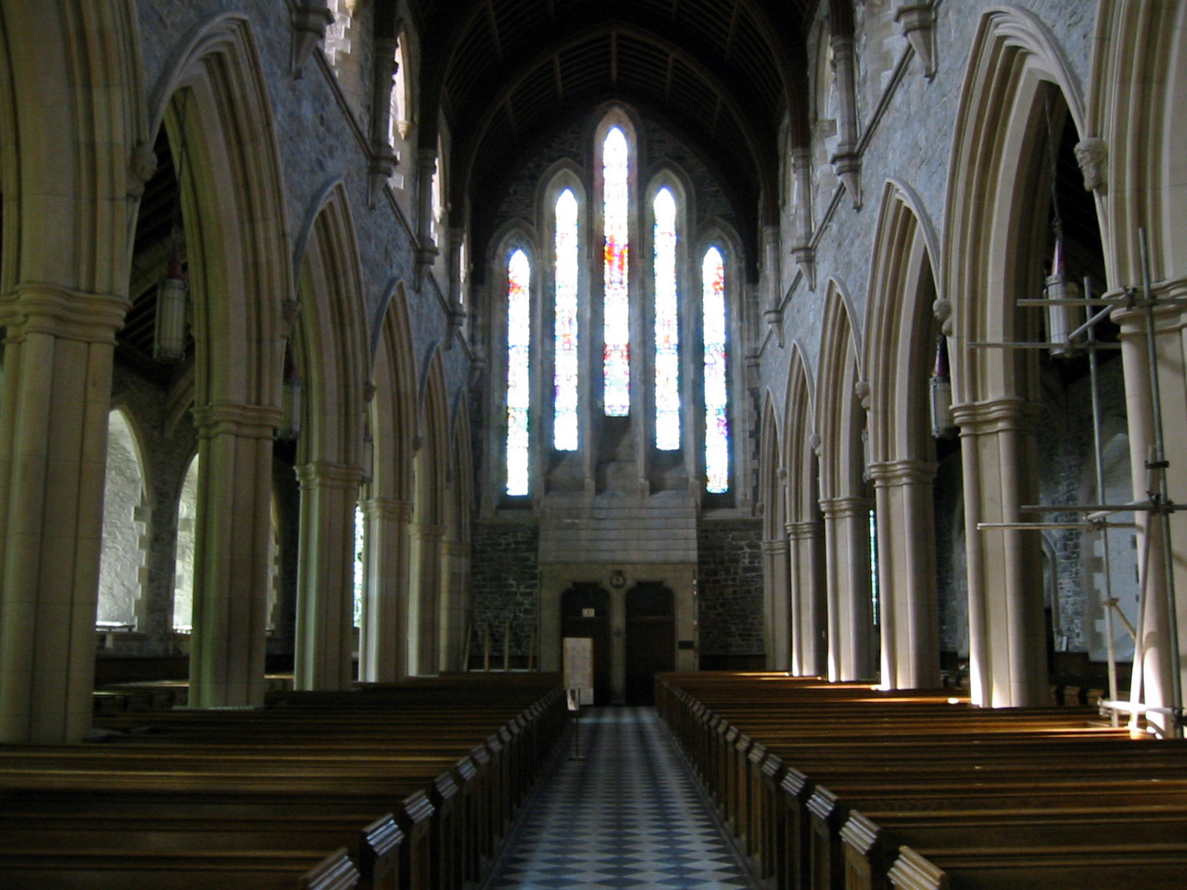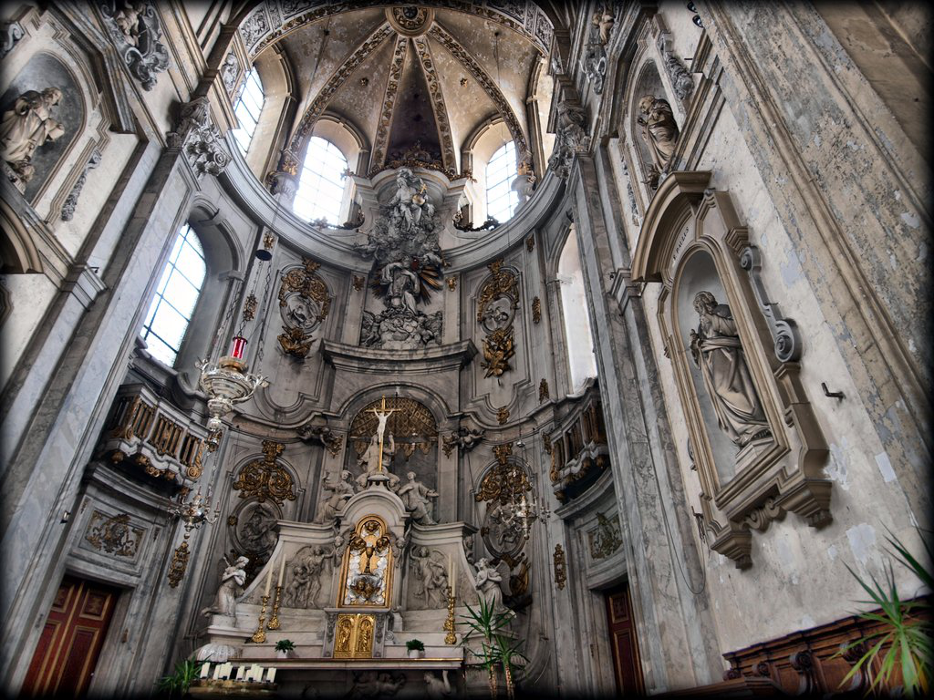
What do you find admirable or impressive?
Activity
These cathedrals were built hundreds of years ago. If you were asked to design a 21st century building to reflect the glory of God, what would you design?
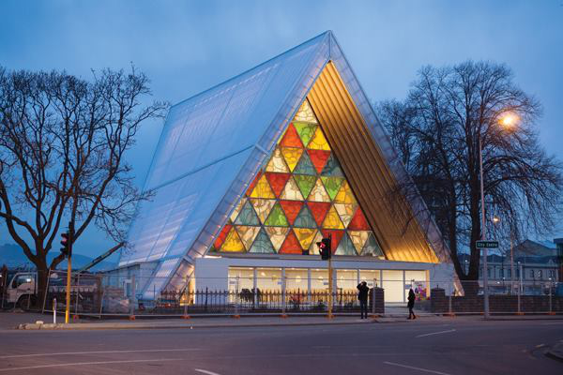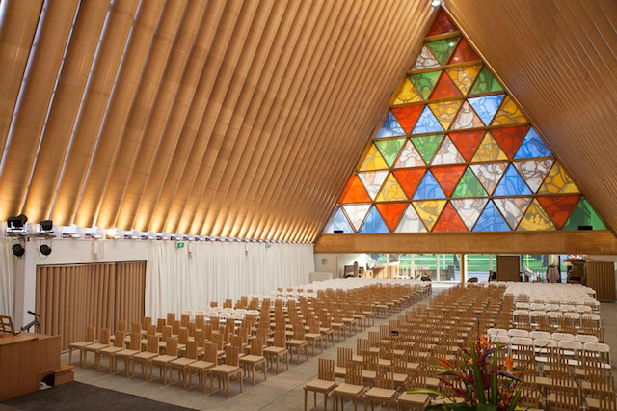
Christchurch Cathedral in New Zealand. It is a temporary space to worship God. Built very recently, it is made mostly from cardboard!

