RE 1.6
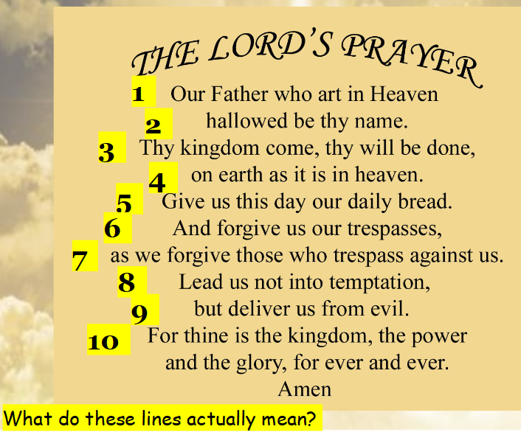

Re write The Lord’s Prayer. Take one line at a time and use your own words.

