Rabbits Home Learning 4.5.20
Hi Rabbits!
I still haven’t heard from any of you for ages now. It would be lovely if you could send me a photo of something you’ve been doing at home! I’ve put lots of lovely activities on our website to help you with your home learning. Let me know how you’re getting on.
Reading: This is from last Wednesday- please log in to your phonics lesson at either 9.30 or 10am (see below)
Dear Parents,

There are fantastic online phonics lessons run by Ruth Miskin who created RWI.
Each lesson is streamed on their youtube channel each day and directed at different ages and abilities.

We will be using this as part of our home learning for the rest of this term.
https://www.youtube.com/channel/UCo7fbLgY2oA_cFCIg9GdxtQ

There is also a story time every day at 2pm on a Monday, Wednesday or Friday.

It really is great as it's run by a trained RWI teacher, so you don't have to do anything! The lesson will be exactly the same format as the ones we do at school so your child should be able to follow and join in maybe just with you sitting or listening nearby.

The lessons are split into 'Set 1, Set 2 and Set 3' sounds.

Please see below for which set of sounds to start with. If you aren't sure which group your child is in, please contact your class teacher.

Group 1: Mrs Golden's Rabbits group (just YR children):
Speed Sounds Set 1 - Reception children
- Set 1 Speed Sounds 9.30 am (BST)
- Set 1 Word Time 9.45 am
- Set 1 Spelling 10.00 am
Group 2: Mrs Golden's Y1/YR group:
Speed Sounds Set 2 - for children in Reception that can read Set 1 Speed Sounds and for children in Year 1 and 2
- Set 2 Speed Sounds and Word Time 10.00 am
- Set 2 Spelling 10.15am
Please email me if you’re not sure which group your child is in. Most were in the first group.

Maths
Number song counting to 100
https://www.youtube.com/watch?v=bGetqbqDVaA
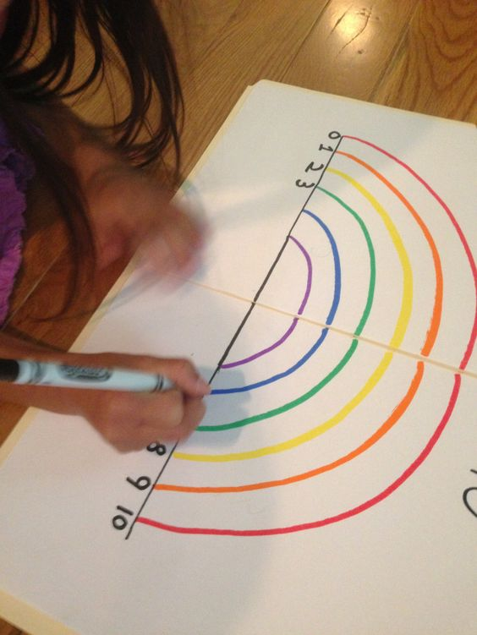
Draw a rainbow… how many colours can you add? Practise your numbers by numbering the colours carefully. You might have more than 10 colours.

If you find this easy try the challenge below.
There is a booklet to print on our class page on the school website too.
Challenge: Try the counting video and activities on this lesson
https://www.bbc.co.uk/bitesize/articles/znfk8xs

