Rabbits Home Learning 11.5.20
Please log in to your online phonics lesson at either 9.30am or 10 am.

We will be using this as part of our home learning for the rest of this term.
https://www.youtube.com/channel/UCo7fbLgY2oA_cFCIg9GdxtQ

Group 1: Mrs Golden's Rabbits group (just YR children):
Speed Sounds Set 1 - Reception children
- Set 1 Speed Sounds 9.30 am (BST)
- Set 1 Word Time 9.45 am
- Set 1 Spelling 10.00 am
Group 2: Mrs Golden's Y1/YR group:
Speed Sounds Set 2 - for children in Reception that can read Set 1 Speed Sounds and for children in Year 1 and 2
- Set 2 Speed Sounds and Word Time 10.00 am
- Set 2 Spelling 10.15am
Please email me if you’re not sure which group your child is in. Most were in the first group.
If you miss the time you can catch up any time on the YouTube channel.

Maths
Number song counting to 100
https://www.youtube.com/watch?v=bGetqbqDVaA
Log onto White Rose maths below and try some of the activities. There’s a short video to go with each activity.

https://whiterosemaths.com/homelearning/early-years/
please try Summer term week 4.
Please let me know how you get on. I’d love to see some photos.

Knowledge and Understanding of the World
This week we are carrying on with ‘The Hungry Caterpillar’

Please draw a picture from the story and add 1 sentence about the story.
For example, “The sun came up.” Or “He ate plums.”
Use your sounds to write the words. It doesn’t matter if your words aren’t spelled perfectly, just try your best.
Don’t forget your finger spaces!
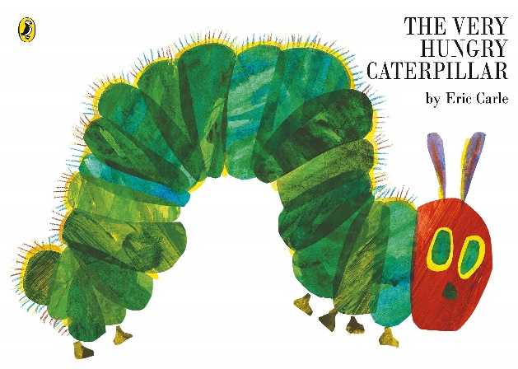
Please send me a photo of your sentences or your craft activities from last week to
Rgolden@charing.kent.sch.uk
https://www.youtube.com/watch?v=75NQK-Sm1YY

There are some ‘Hungry Caterpillar’ activities attached if you have access to a printer.
If you can’t print the days of the week, please write these out on paper with the pictures of the fruit from the story.
Try getting your child to order them.

