Rabbits Home Learning 15.5.20
Please log in to your online phonics lesson at either 9.30am or 10 am.

We will be using this as part of our home learning for the rest of this term.
https://www.youtube.com/channel/UCo7fbLgY2oA_cFCIg9GdxtQ

Please use the ‘At home with Handwriting’ sheets attached.
If you can’t print, read these words out to your child one at a time. Ask them to write the word and draw a picture.
six box bat pen log challenge: chip ship queen
Try writing a simple sentence, eg, I can see a bat.

Maths
I have included a maths practise sheet.
If you can print these, complete them, making sure you are forming your numbers correctly.
If you can’t print the sheets, make your own number line to 10 or 20. Or make a hopscotch up to 10.
Remember a 9 looks like this…
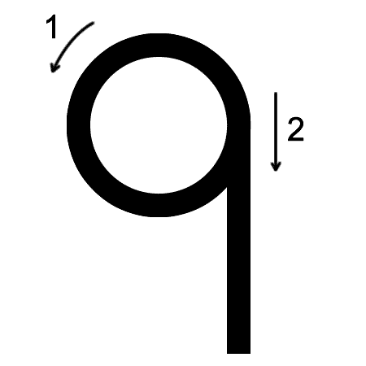
Watch the link below to remind you how to write your numbers.
https://www.youtube.com/watch?v=VlfQhHQAUCY

I would like you to send me a photo of one of the pieces of your work today.
For more activities please email me and to email me pictures of the work you have been doing…
Rgolden@charing.kent.sch.k

