Rabbits Home Learning 18.5.20
Please log in to your online phonics lesson at either 9.30am or 10 am.

We will be using this as part of our home learning for the rest of this term.
https://www.youtube.com/channel/UCo7fbLgY2oA_cFCIg9GdxtQ

Writing

This is our story for this week. If you don’t have a copy watch the link below.
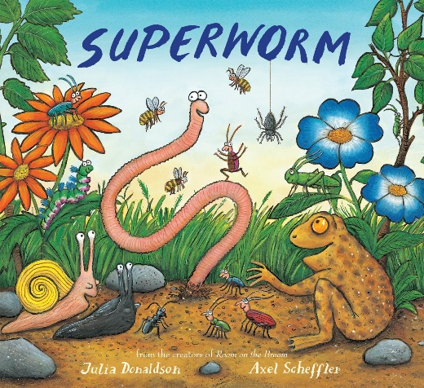
https://www.youtube.com/watch?v=7Jnk3XApKBg
Watch and listen to the story.
Draw a picture of all the mini beasts from the story.
Try to write their names using the sounds you can hear.

Maths

https://whiterosemaths.com/homelearning/early-years/
Complete day 1 activities using the story of ‘Superworm’
I have also attached some colouring pictures from the story

Remember you can always use the link below to help you practise your numbers.
https://www.youtube.com/watch?v=VlfQhHQAUCY

We will be dong lots of activities based on this story this week.
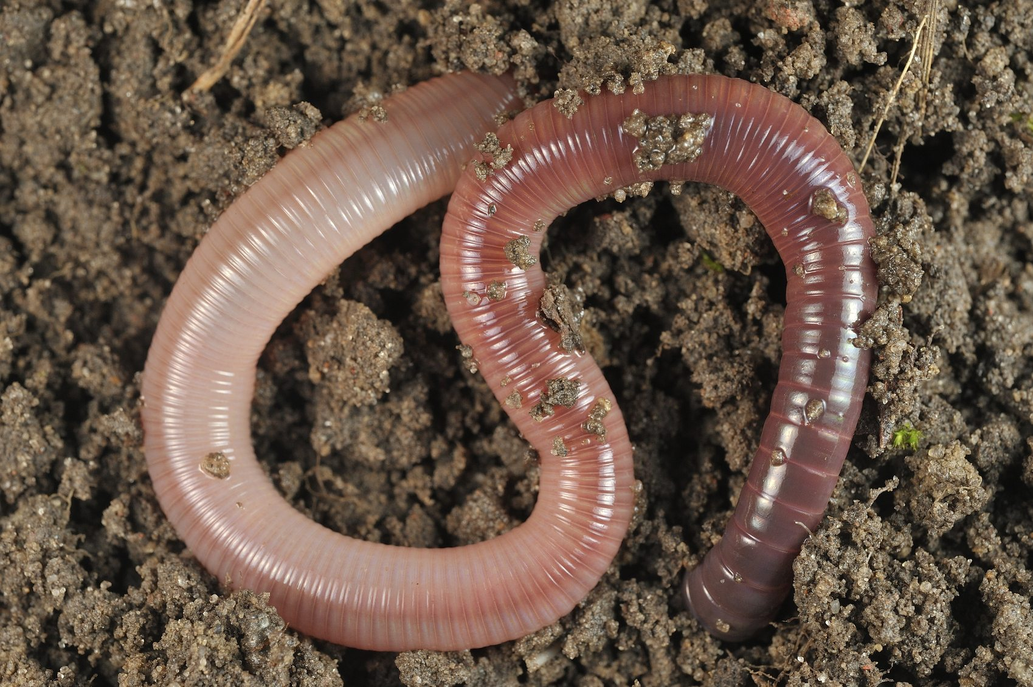
Is there anywhere you can dig in your garden. Can you find any worms? What do you notice about them?
Be careful not to hurt them though.

I would like you to send me a photo of one of the pieces of your work today.
For more activities please email me and to email me pictures of the work you have been doing…
Rgolden@charing.kent.sch.k

