Rabbits Home Learning 18.5.20
Please log in to your online phonics lesson at either 9.30am or 10 am.
Set 1 sounds (most children)
Set 2 sounds (4 of the girls from Rabbits who joined the Y1 group)

Please email me if you’re not sure which group.

We will be using this as part of our home learning for the rest of this term.
https://www.youtube.com/channel/UCo7fbLgY2oA_cFCIg9GdxtQ

Writing

This is our story for this week. If you don’t have a copy watch the link below.
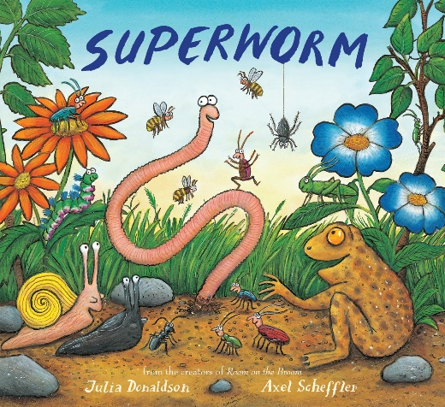
https://www.youtube.com/watch?v=7Jnk3XApKBg
Watch and listen to the story.
What is Superworm like?
Ask your child to think of a sentence about Superworm (ie, He is strong.)
Help your child to identify the sounds in the words and write them down, encouraging them to use finger spaces.

Maths

https://whiterosemaths.com/homelearning/early-years/
Complete Day 2 activities using the story of ‘Superworm’
I have also attached some mini beast colouring pictures.

Remember you can always use the link below to help you practise your numbers.
https://www.youtube.com/watch?v=VlfQhHQAUCY

We will be dong lots of activities based on this story this week.
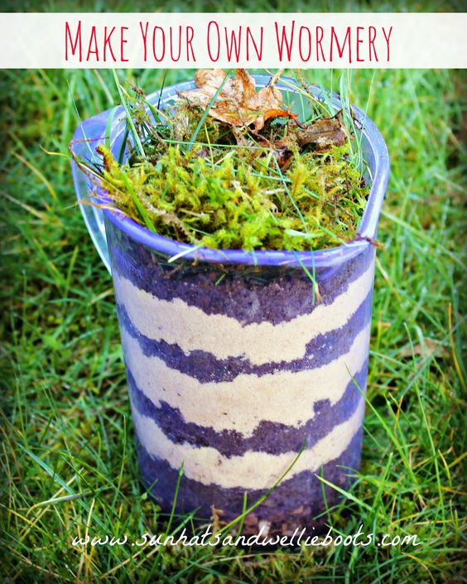
Try one of the activities.
You could also try making your own worm with anything you have at home…
You could use play dough, make salt dough (google a recipe), scrunched up paper or make a giant worm with cushions and blankets.

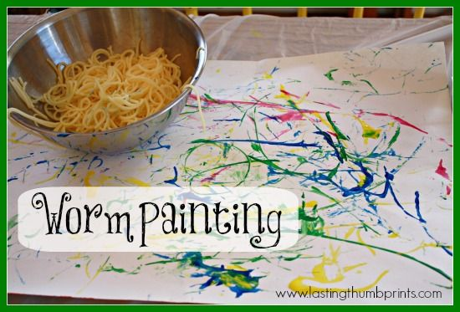
Is there anywhere you can dig in your garden. Can you find any worms? What do you notice about them?
Be careful not to hurt them though.

I would like you to send me a photo of one of the pieces of your work today.
For more activities please email me and to email me pictures of the work you have been doing…
Rgolden@charing.kent.sch.k

