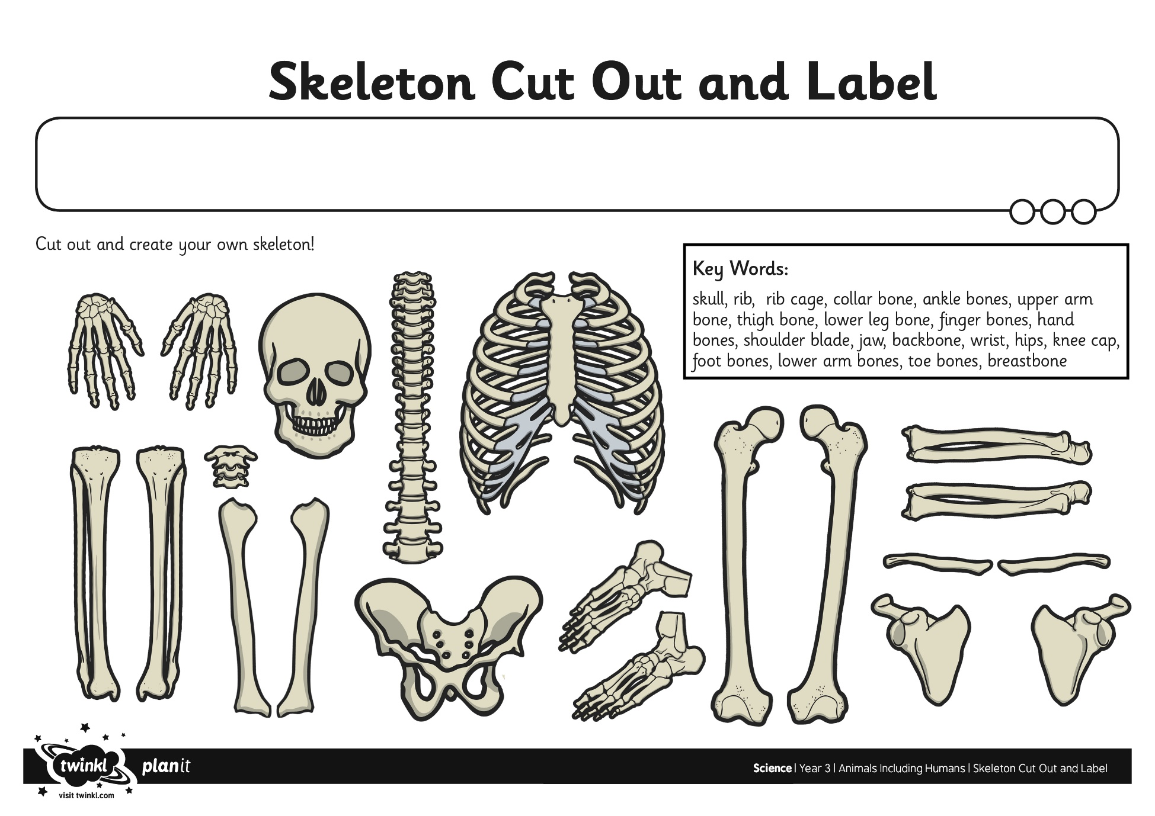
Science 1.5

Watch the following video:
https://www.bing.com/videos/search?q=how+the+lungs+work+ks2&&view=detail&mid=93B673CFAEA11B6ADB8E93B673CFAEA11B6ADB8E&&FORM=VRDGAR&ru=%2Fvideos%2Fsearch%3Fq%3Dhow%2520the%2520lungs%2520work%2520ks2%26qs%3DAS%2

Log on to the following website to make your own lung
https://www.bing.com/videos/search?q=animals+including+humans+year+6+&&view=detail&mid=9A9D4C2B20A8B958AA689A9D4C2B20A8B958AA68&&FORM=VRDGAR&ru=%2Fvideos%2Fsearch%3Fq%3Danimals%2Bincluding%2Bhumans%2Byear%2B6%2B%26FORM%3DHDRSC3
