Science:
Hello Foxes Class, I hope you are all well. Today we are going to be learning about ‘Types of Skeletons.’
- Go through the PowerPoint labelled ‘Types of Skeleton.’
- Follow the slides and answer the questions with your adult.
- You will come to an activity page. These activities are below:
To answer the sheets, you can:
- Print and cut onto the correct skeleton type.
- Split a piece of scrap paper into 3, label them with the correct skeletons and draw the pictures onto the right section. (Use the sheets below for reference)

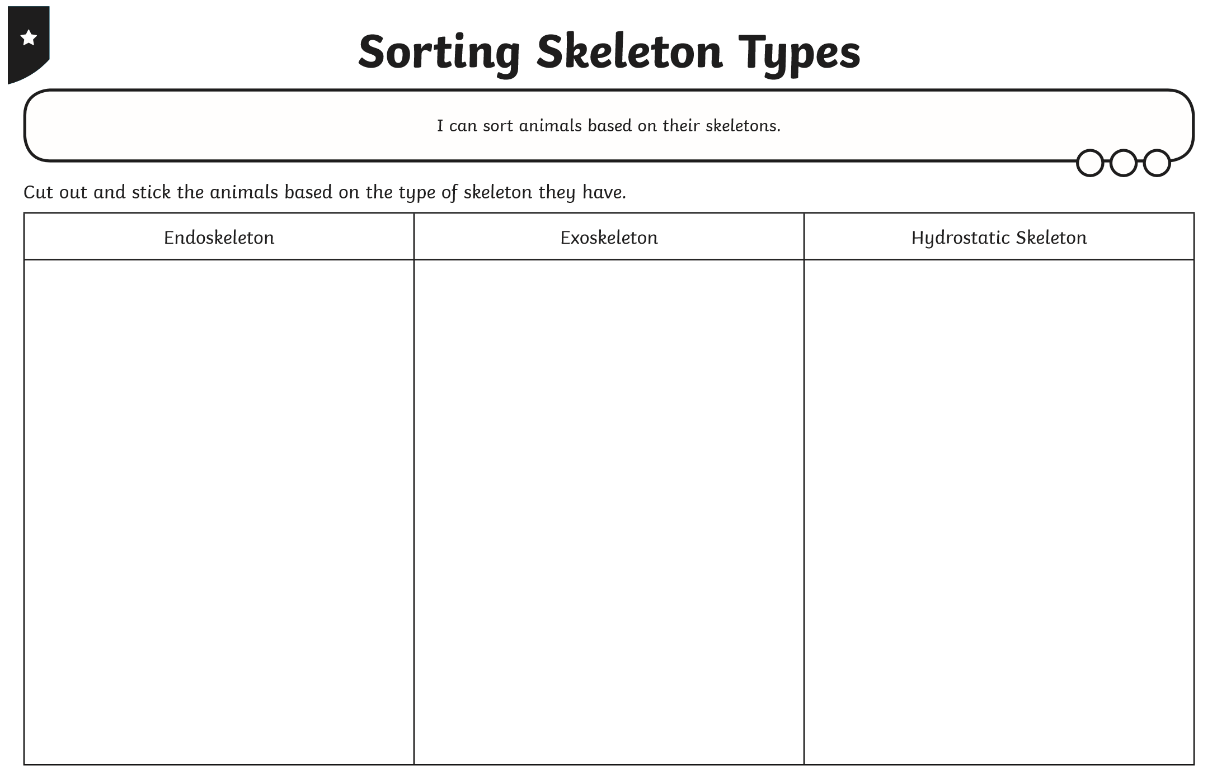
Green: The animals are on the next page.
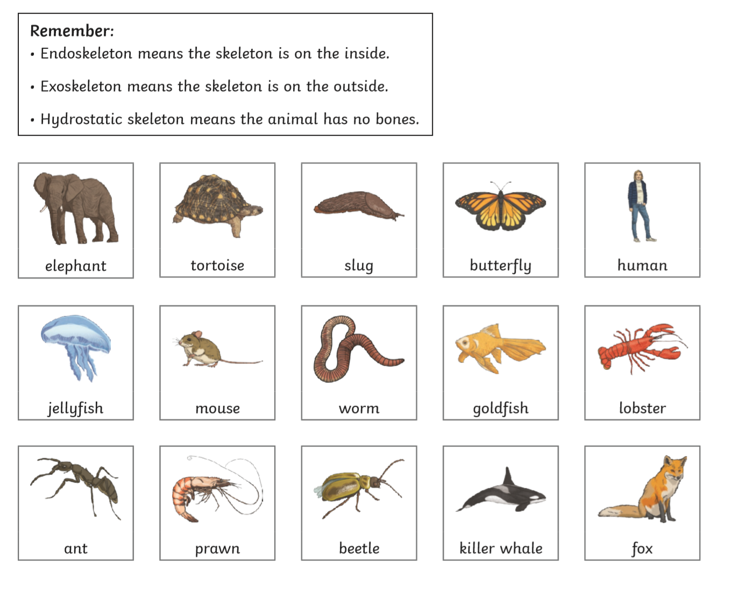

Red: The animals are on the next page.
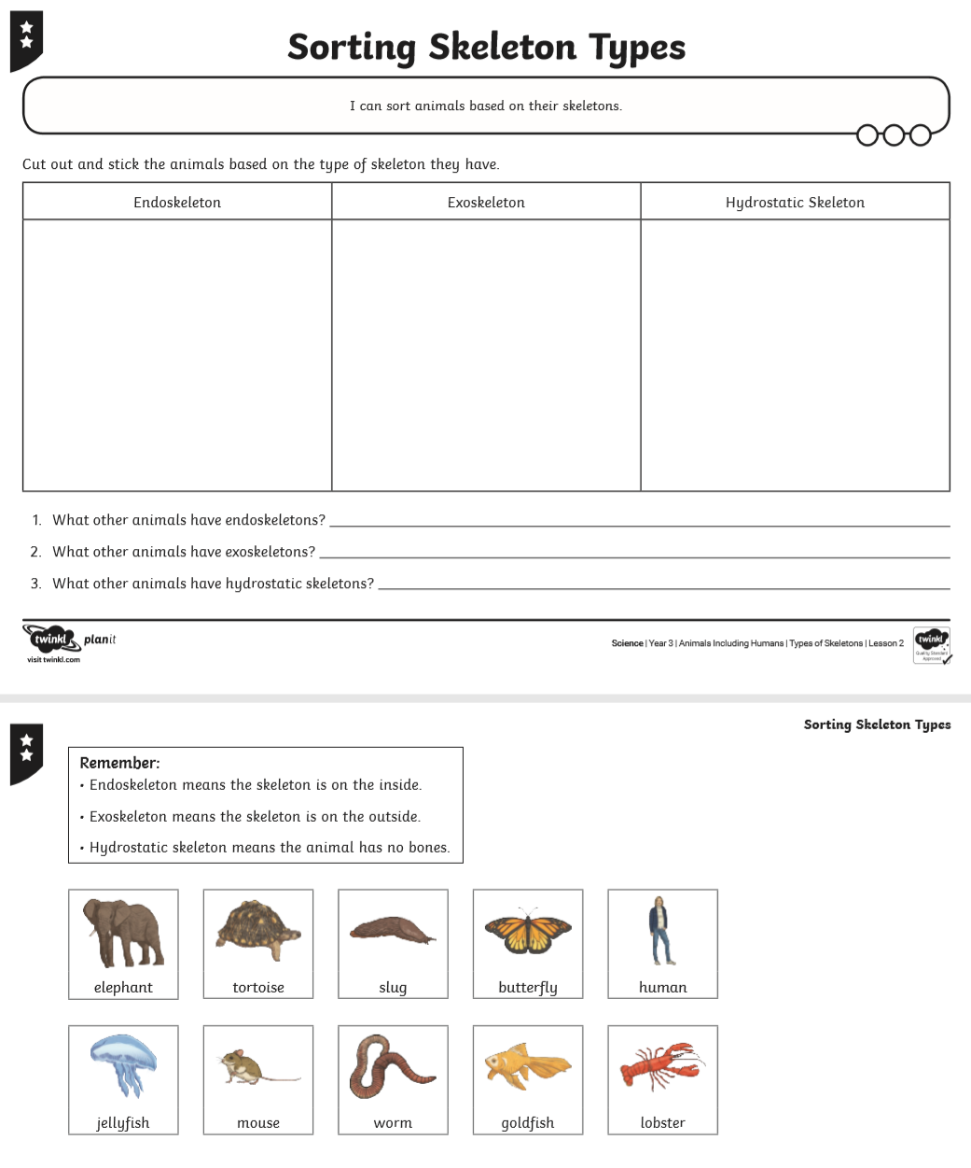

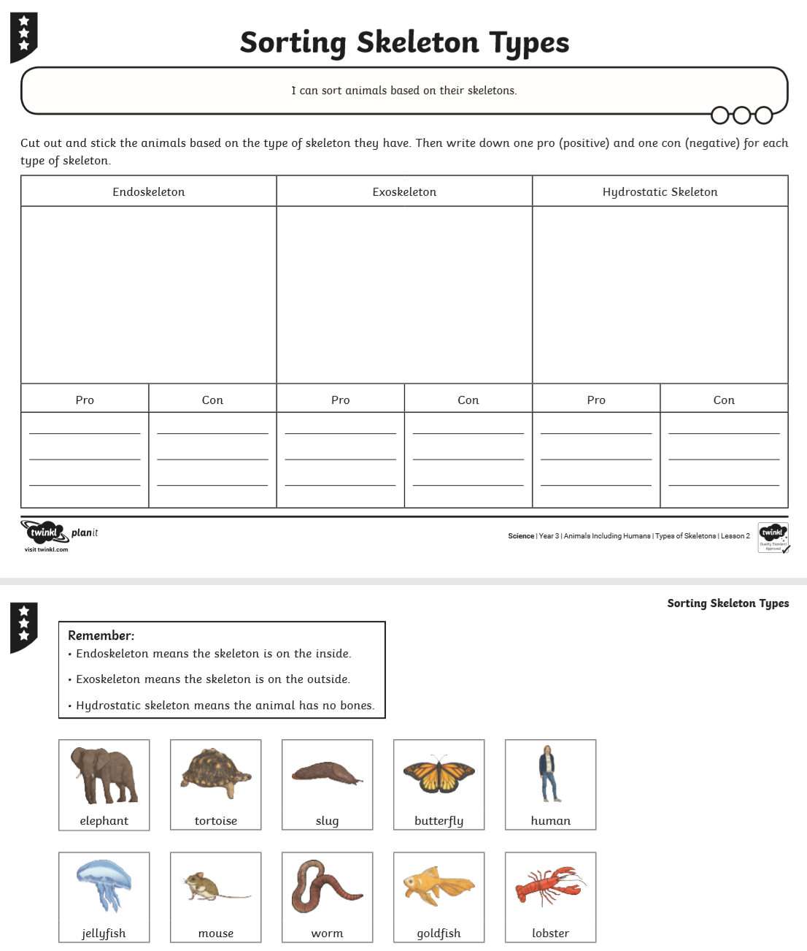
Blue: The animals are on the next page.

