Science: Mighty Muscles
Questions: Watch the series of videos to help you answer them on scrap paper.
https://www.bbc.co.uk/bitesize/topics/z9339j6/articles/zpbxb82
https://www.bbc.co.uk/teach/class-clips-video/science-ks2-how-do-muscles-and-bones-work/zfgtscw
- What do our muscles do?
- How are our muscles attached?
- How many muscles are there in the human body?
- Can muscles only push or pull?
- What are the names of the two muscles in our arms?

Go through the PowerPoint named ‘Mighty Muscles.’
In that there will be information about muscles and their role in the body.
Today’s main activity is going to be experimental:
- Think about the muscles in your body.
- Below there is able of movements.
- Before doing the movement, predict what muscles you will use and mark them on the diagram.
- Then complete the movement and see what muscles you use.
- The first one is done for you.

Movement | Prediction – Circle which muscles you think will be used. | Results – After you have completed the activity, see if there are any other muscles that might be used.
Running:
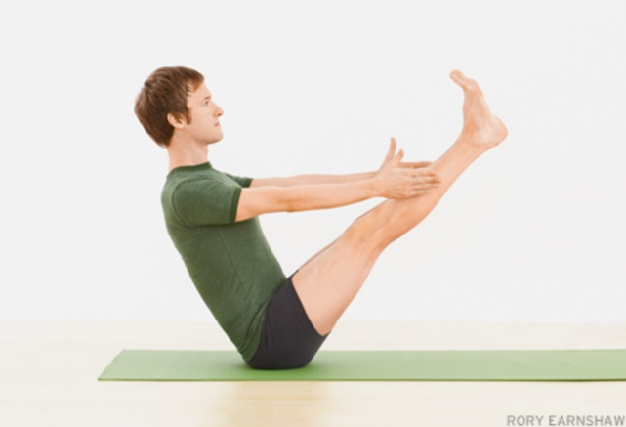
Boat Pose:
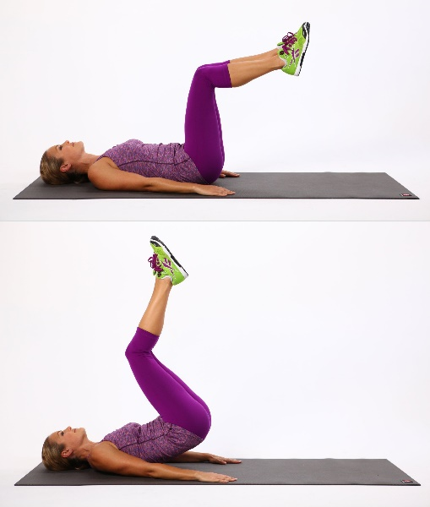
Reverse Crunch:
Chest Press:
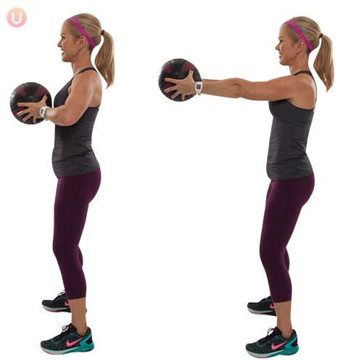
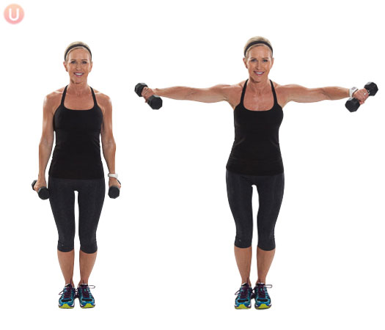
Lateral Raises:

