Science 7.5 Circulatory system
Go to the following web page:
https://www.bbc.co.uk/teach/class-clips-video/science-ks2-how-our-circulatory-system-keeps-us-alive/zhf76v4
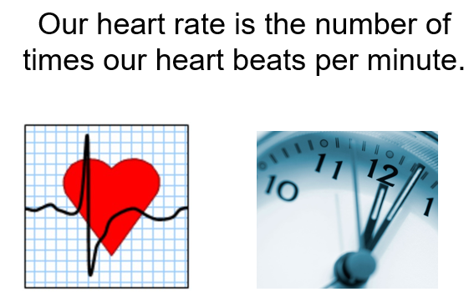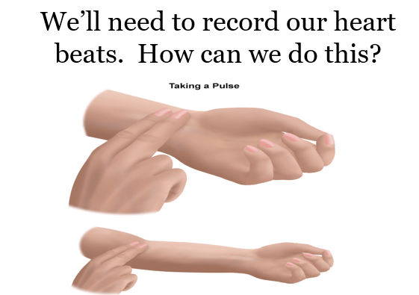

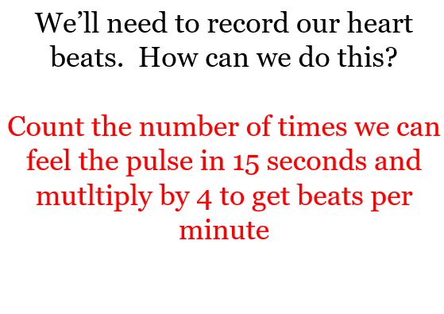

Activity
- Stay sitting down. Count your pulse for 15 seconds. Multiply the answer by 4. Record your answer.
- Slow your breathing down - breath in for 2 seconds – hold your breath for 2 seconds – breath out for 2 seconds. Take your pulse and record the answer.
- Walk around normally for 1 minute. Take your pulse and record your answer.
- Jog n the spot for 1 minute. Record your pulse rate.
- Jump up and down for 1 minute. Take your pulse and record.
- Sprint for 1 minute. Take your pulse and record.

Use the sheets below as an example to record and produce your own graph to show how your heartbeat changes.

