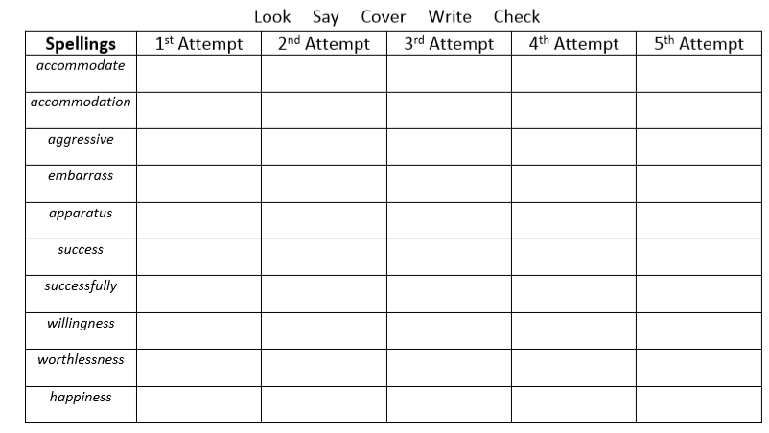
Challenge- Choose five of the words above and use them to write your own similes and metaphors. Can you use hyperbole?

