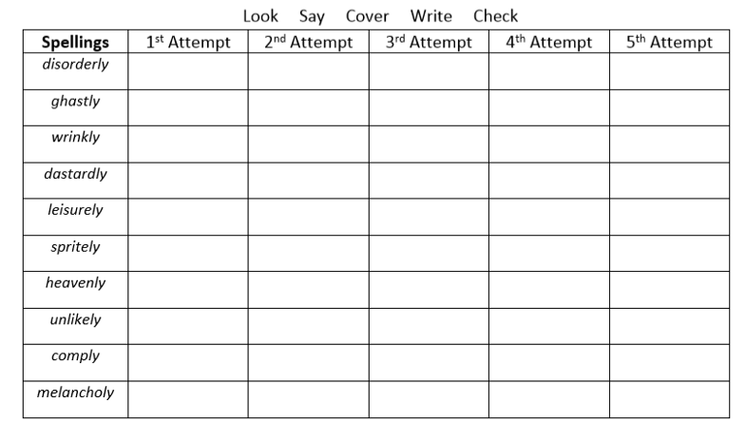
Write 10 sentences using these words correctly. Use a dictionary to help.

