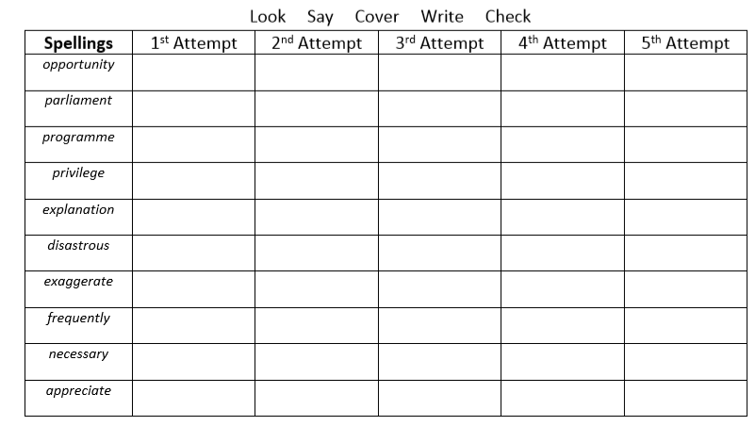
Challenge – Pick 5 and write your own dictionary definition.

