Mon 4th May
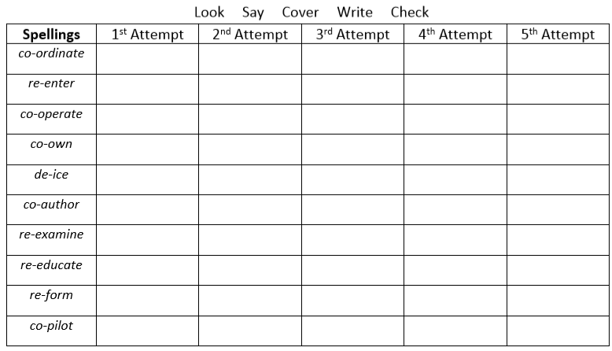
Challenge
Write sentences using these words correctly. Use a dictionary to help you understand the correct meaning.

