Squirrels – English 06.05.20
Year 2
If you wish to continue with Oak academy lessons please see option 1, otherwise go straight to option 2.
Option 1
Log on to the following link and complete the activity.
https://www.thenational.academy/year-2/english/to-identify-and-use-adverbs-year-2-wk1-4
Option 2
Think of different questions you could ask about the picture. Here are your question words:
Who, what, when, where, why, how

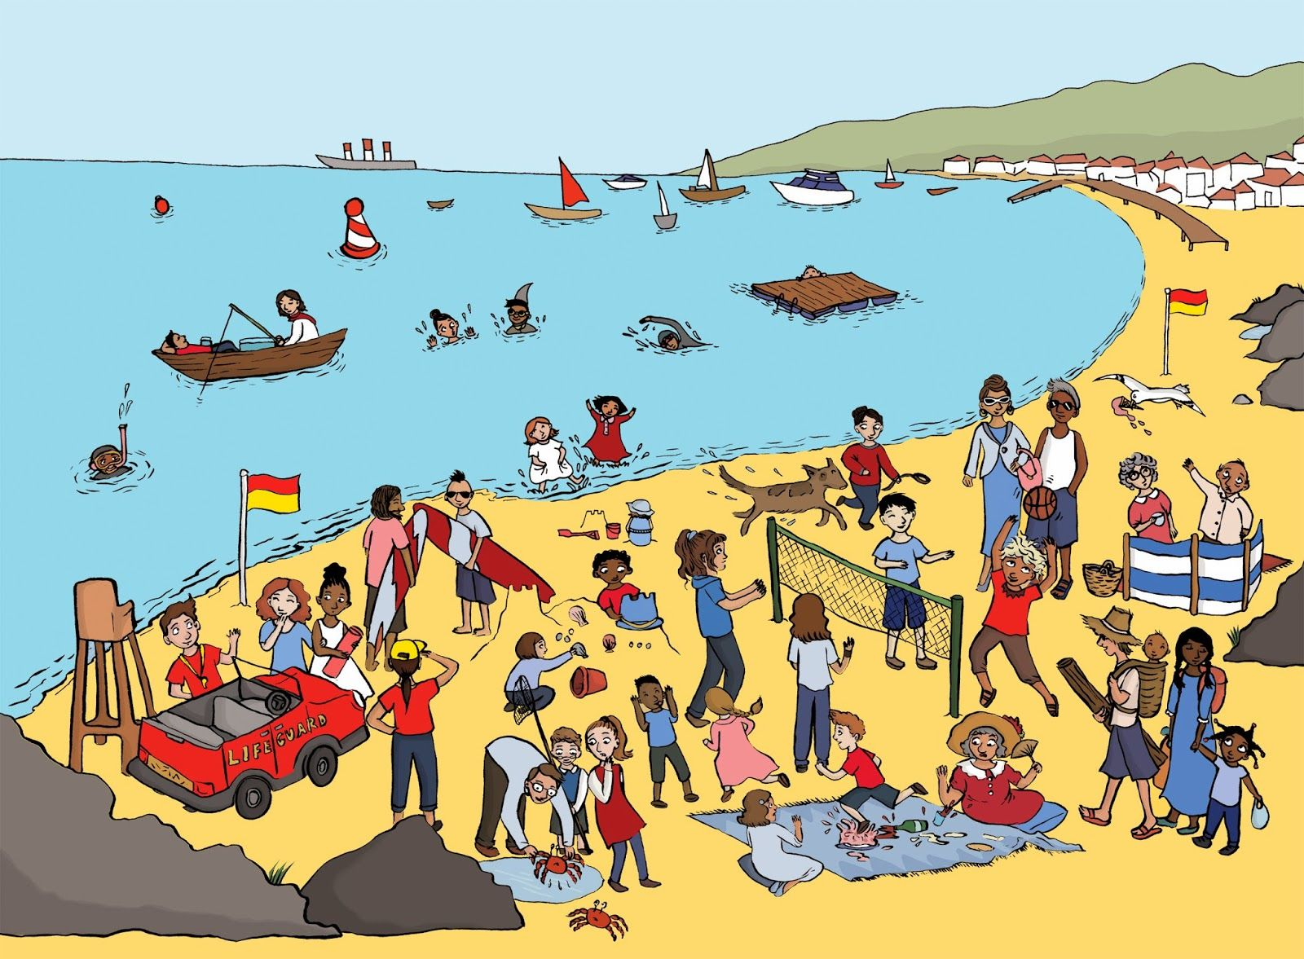
Word bank:
Beach, sea, sandcastle, lighthouse, café, picnic, sunny, swim, beach hut, boat, seagull, paddle

Year 1

Imagine you went to bed and when you woke up, you had shrunk to the size of a flower! Write some sentences on what might happen next!
Challenge
Can you write a story explaining what happened next?
