Squirrels – English 06.05.20
Year 2
Please see reading comprehension activity (uploaded as a separate document under today’s tasks).
Make sure you don’t peek at the answers before you try the questions!

Year 1

Can you design a superhero costume? Now describe your picture in some words.
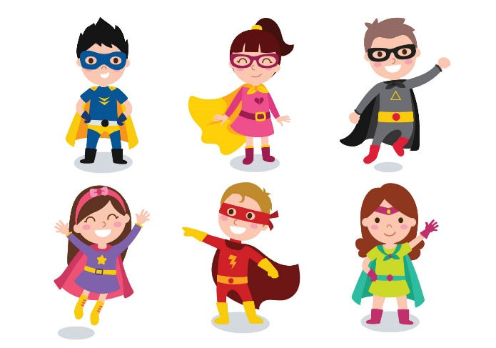
Challenge
Can you write a simple description about your superhero using lots of adjectives and explain some of its super powers?

