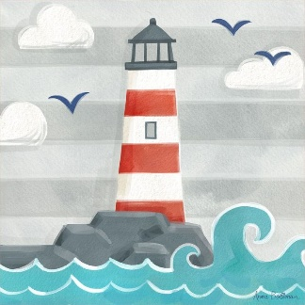
Topic- 01.05.20

Can you remember the main parts of a Lighthouse? This week there is an information sheet with some comprehension questions to answer.
Please encourage your child to read if they are able, if it is a little tricky please read with them. I have included two different abilities, please select the option most suited to your child.

This short video ’ A Day in the Life of a Lighthouse Keeper’ from National Geographic gives an insight into a lightkeepers day.
https://video.nationalgeographic.com/video/short-film-showcase/0000014c-759f-d234-affd-ffdf65cc0000
Questions to think about-What do you think? Would you like to have this job? Any similarities between our lockdown and the lightkeepers job?

