Topic
Click on the slides labelled ‘Complete Castles (Slides 2)’
- Look through the slides and learn about ‘William the Conqueror.’
- Discuss the questions with your adult.
- Complete the activity below according to ‘Green, Red or Blue.’
- There are ‘Fact Cards’ below to help you.
- There is also a Challenge at the end of this document.

Fact Cards:
The first Norman Castles were motte and bailey. | This castle was quick to build. | This castle took a long time to build. | This castle could rot or catch fire.
This castle was made from stone. | This castle was made from wood. | Later on the Normans built Keep and Bailey castles. | Some of these castles are still used today.

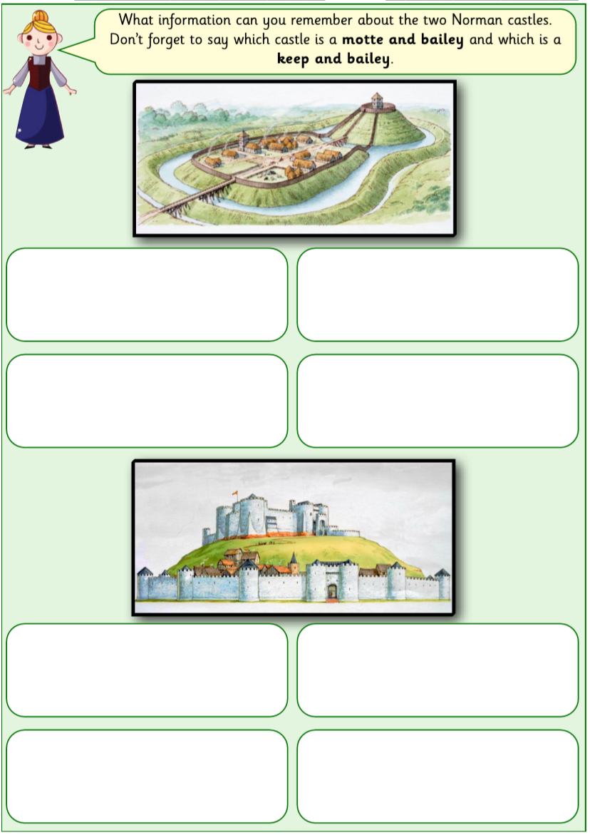
Green/Red– You can write your answers on scrap paper or use this worksheet.

Blue – Write your answers on Scrap Paper so you have more space to write.
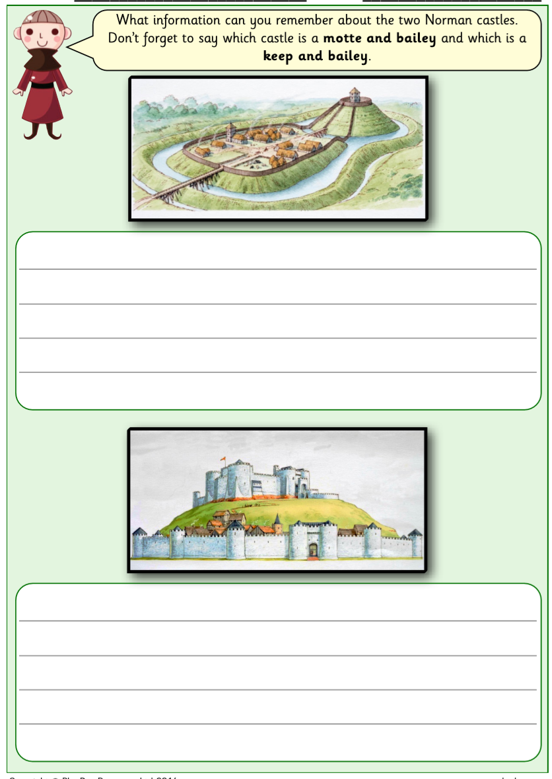

Challenge: Have a go at writing detailed answers using the internet for research.
