Topic
Can you remember who this is?
Why is she famous?
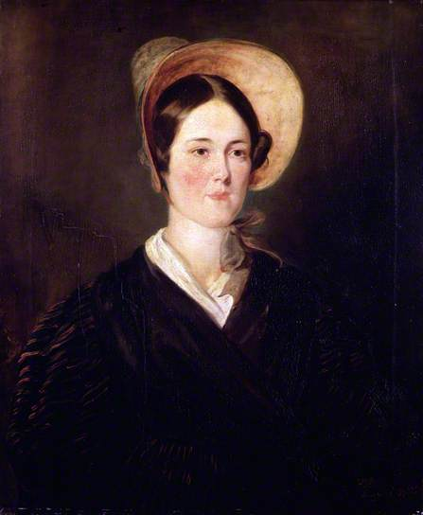

This is a picture of Grace Darling. She was a lighthouse keeper’s daughter who lived a long time ago, she was born in 1815. She helped her father save people who been in a shipwreck during a storm.
This is last week’s video we watched https://www.youtube.com/watch?v=xCL1x7wHQLY

Here is another video about Grace Darling https://www.bbc.co.uk/programmes/p015gmjd

How do you think Grace, her father and the survivors would have felt that night? Can you complete the thought bubbles for each of them?

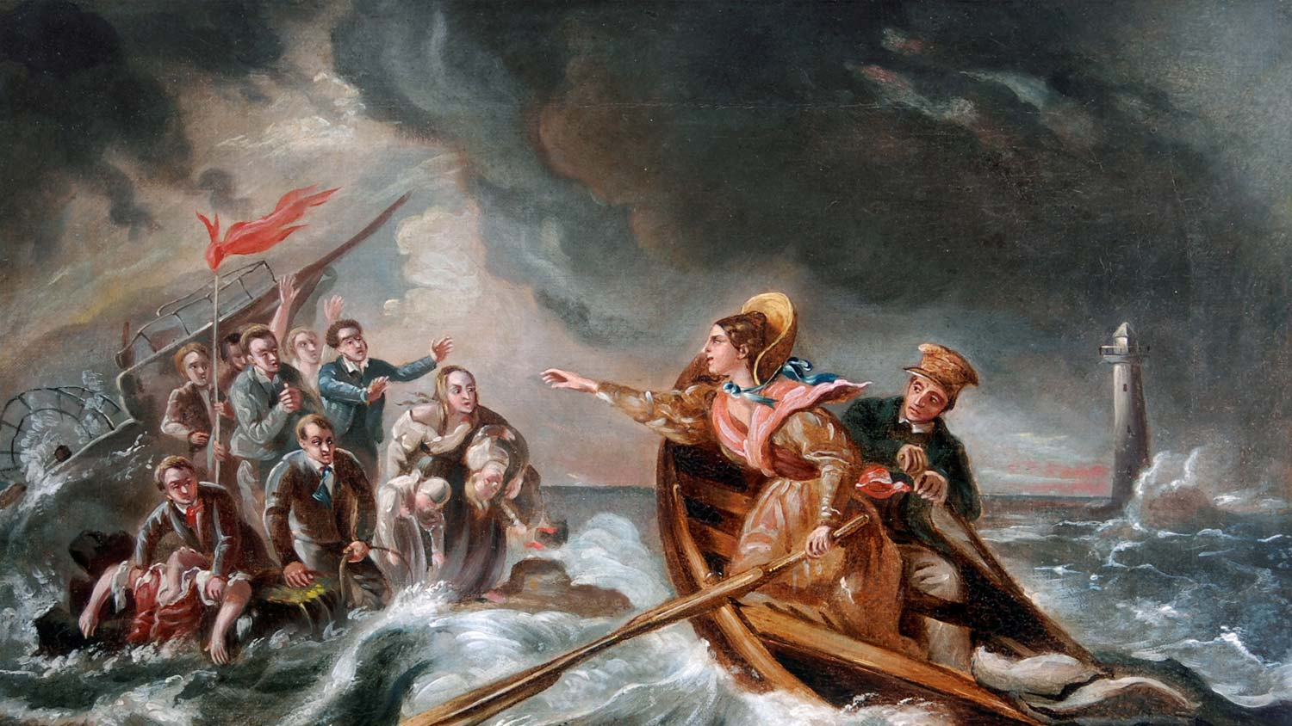

Challenge- Can you write a diary entry that Grace may have written that night?
Include what she did and how she felt before, during and after the rescue.

