Topic
Do you know who this is?
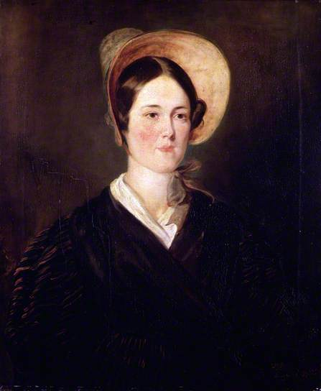

This is a picture of Grace Darling. She was a lighthouse keeper’s daughter who lived a long time ago, she was born in 1815. Why do you think I have used a painting not a photograph?
She was a heroine and is still remembered for her bravery. I have put a Powerpoint on here for you to read through (or with an adult) and also this video link on YouTube ‘The Story of Grace Darling, BBC Teach’ https://www.youtube.com/watch?v=xCL1x7wHQLY
Can you find out how she was so brave? Then draw a timeline and order some main events in Grace’s life? You can make these up yourself after reading the information or use the sheets provided.

