Using Cohesive Devices Information
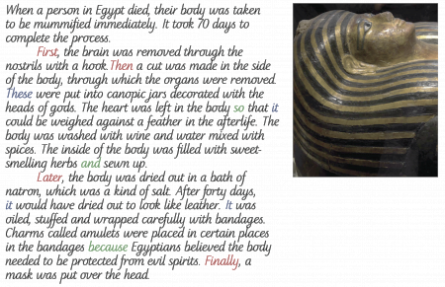
This piece of writing shows how cohesive devices can be used:
The time connectives (in red: first, then, later, after, finally) are used to show that this is a process that has several steps and an end goal. These words are also adverbs, because they tell us when something is done.
Pronouns (in blue: these to refer to the organs and it to refer to the body) are used to show that the writer is referring back to a person or object already named.
Conjunctions (in green: and, so, because) are used within sentences to link ideas within a sentence.

