Year 3 Maths
Multiplying and Dividing by 3:
- Follow this link - https://www.bbc.co.uk/bitesize/articles/zbkvbdm
- Go through ‘Learn’ and watch the videos on this topic.
- Then go through ‘Practise.’
Activity 1: The worksheet is below. You can find answers on BBC.
Activity 2: Click on the link and work through the questions.
Activity 3: Click on the link and watch the 2 videos under ‘Learn.’
- https://www.bbc.co.uk/bitesize/articles/znfj7nb
- Below there are some questions under ‘Activity 3.’ I have given you some scenarios which I would like you to share into ‘equal groups’ using the 3x table.

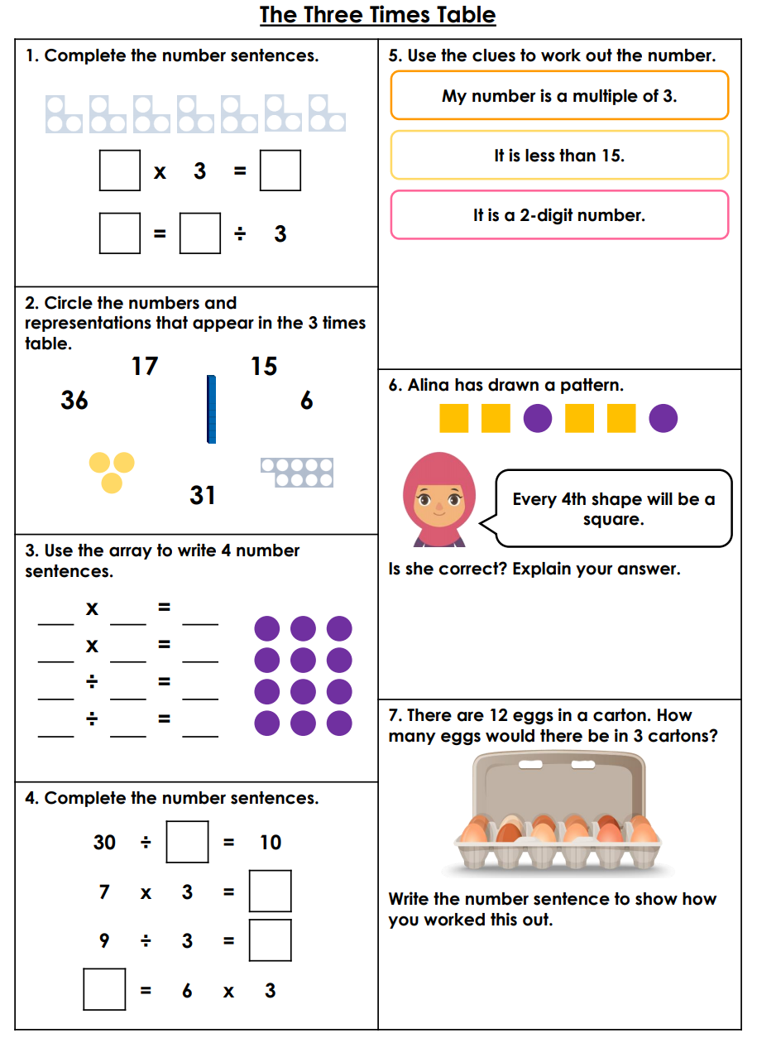
Activity 1:
Activity 3:
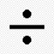
1. Share these 15 pencils into 3 equal groups. (15 3 = )

Sentence: 15 pencils can be shared equally into 3 groups to make________________________.

2. Share these 24 ice-creams between 3 equal groups. (24 3 = )

Sentence: 24 ice creams can be shared equally into 3 groups to make _____________________
3. Work out 18 3 =

4. Work out 30 3 =

5. Fill in the missing number to this number sentence:

_______ 3 = 9

Sentence: _________ flowers can be shared equally into 3 groups to make 9.

