Year 4 Maths
Dividing a 2-digit number by 1 digit
- Follow this link - https://www.bbc.co.uk/bitesize/articles/znfj7nb
- Go through ‘Learn’ and watch the videos provided.
- Go through ‘Practise’ and have a go at the activities.
Activity 1 - Click on the ‘Oxford Press, My Maths’ link and click through the numbers down the side of the screen to answer the questions.
Activity 2 – The resources are below or you can answer the questions on scrap paper.
Activity 3 – The resources are below or you can answer the questions on scrap paper.

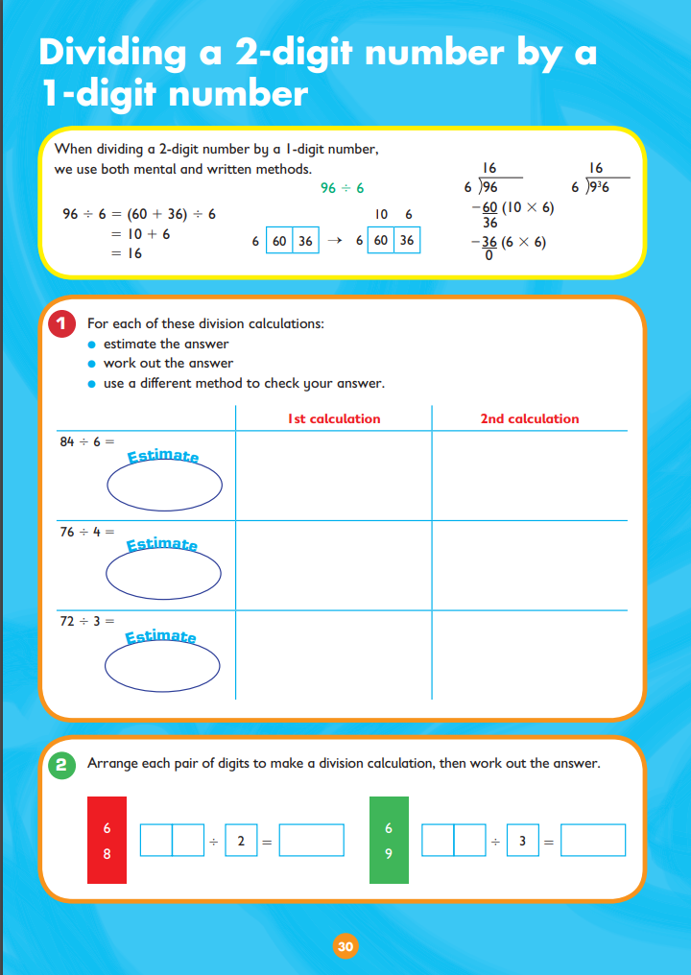
Activity 2:
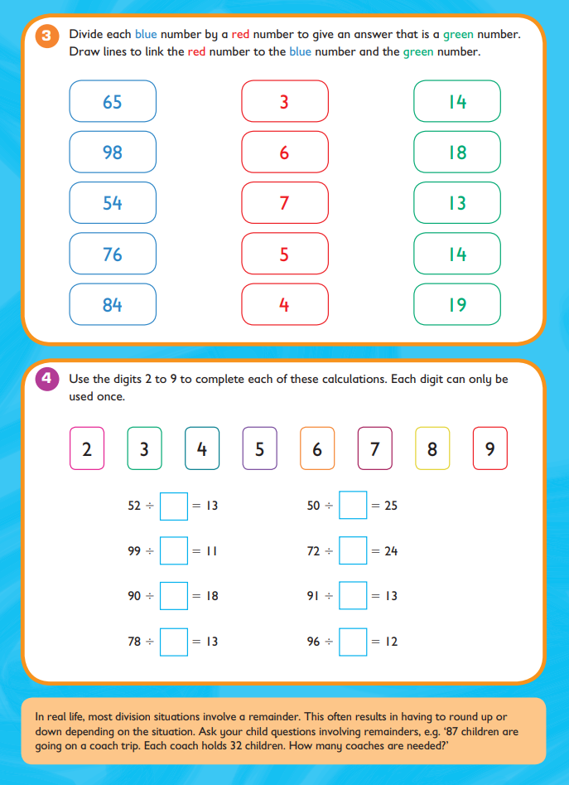

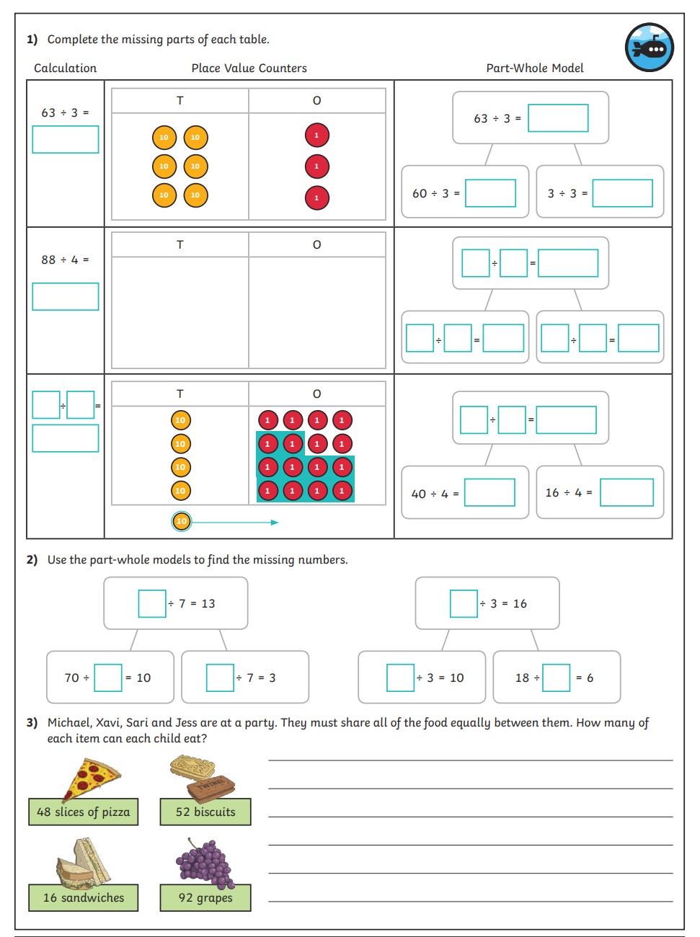
Activity 3:
