Badger’s Science week beginning 27/04/20
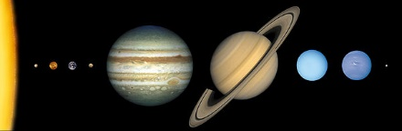

Make a model of our Solar System, be as creative as you want to be – maybe use something something usual to represent the planets and send us a picture when you have finished it!
Make sure the planets are in the correct order and named.

