Art: Explorer Lesson
1. Find some different types of leaves and bark.
2. Place a piece of paper over it and shade lightly using a colouring pencil or pencil.
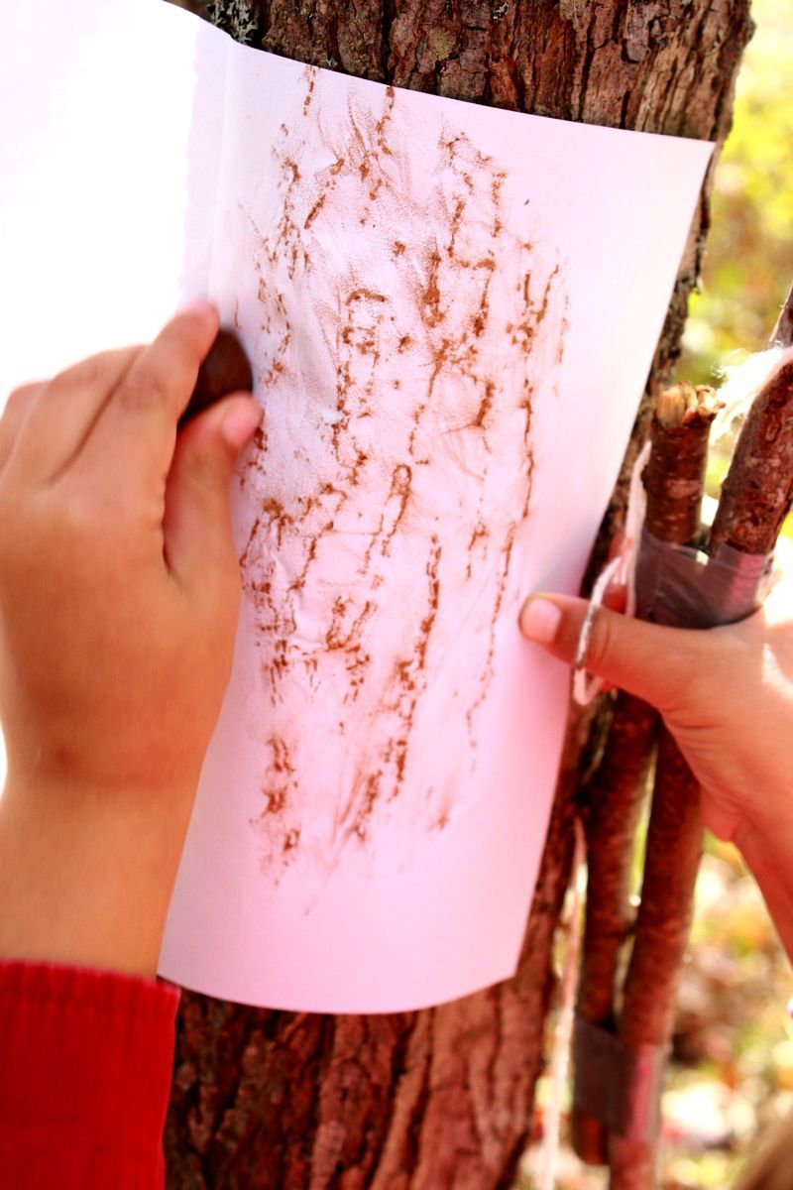
3. You should get something like these…
4. Try and find the leaf of one tree and the bark of the other. Do you know the name of the trees?
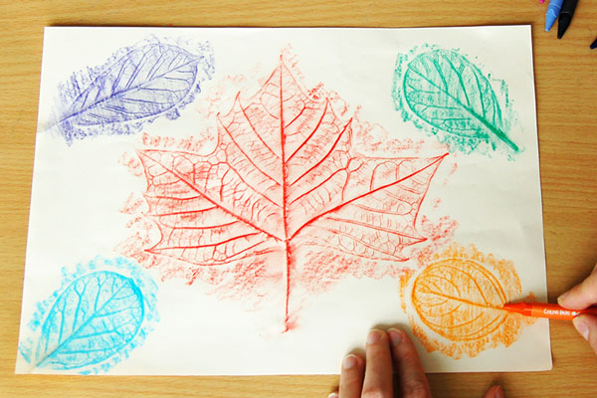

5. See if you can find any other objects that you could create this effect of.

