10.6 William Morris
Look at these examples of wallpaper designed by William Morris.
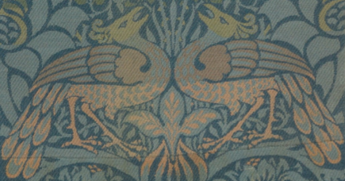

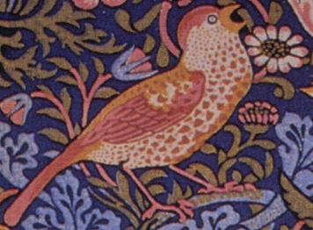

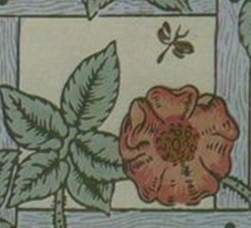
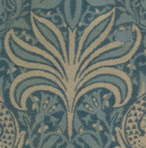
Choose your favourite design and see if you can recreate it. Do a close observational drawing of one of these designs. Remember to look carefully at the detail and include this in your picture.

