5.6 Art
William Morris
Go to the following web page:
https://www.bing.com/videos/search?q=william+morris+ks2+video&docid=608050532902700180&mid=4E0E0A85FE0ACEC46FFA4E0E0A85FE0ACEC46FFA&view=detail&FORM=VIRE
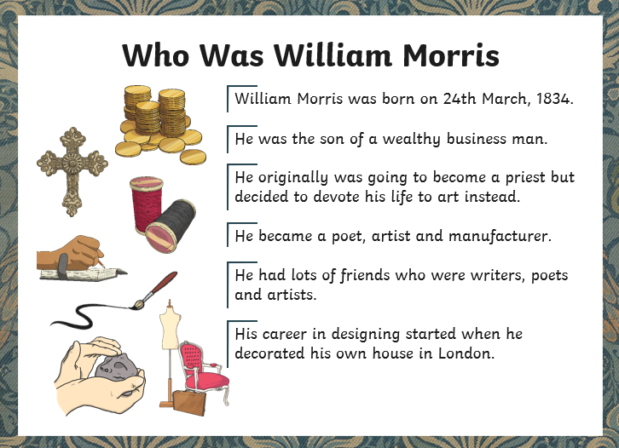

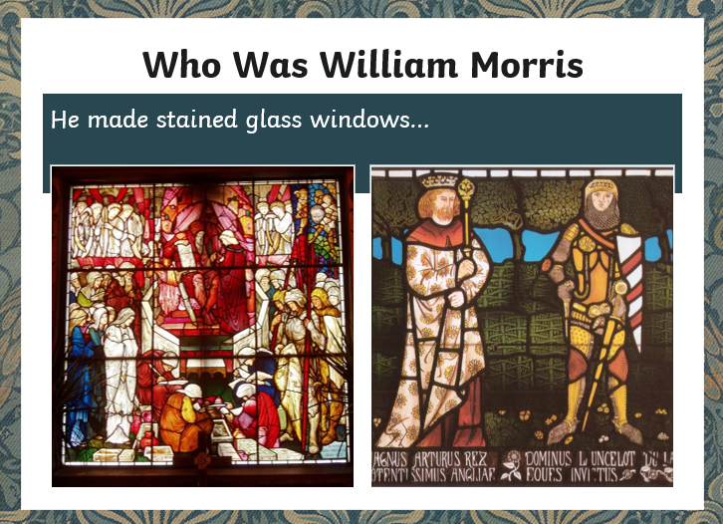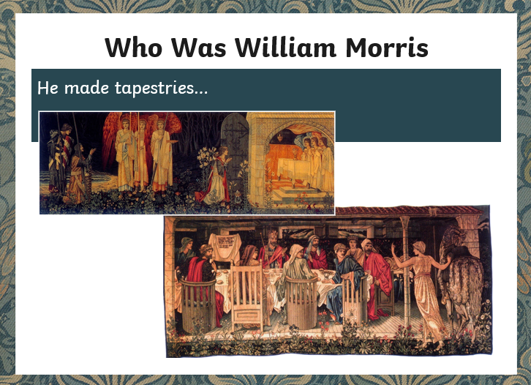
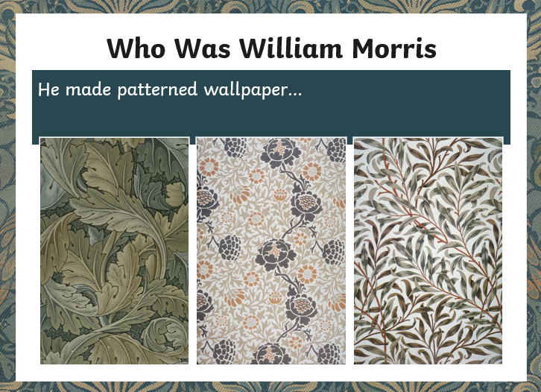

William Morris was famous for his wallpaper designs. He created some beautiful designs which were mainly around the theme of flowers, plants and birds.

Activity
Use some of his ideas below to create your own wallpaper design.
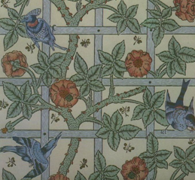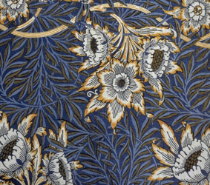
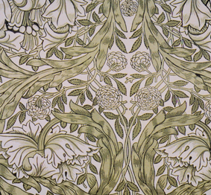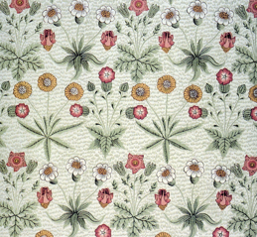

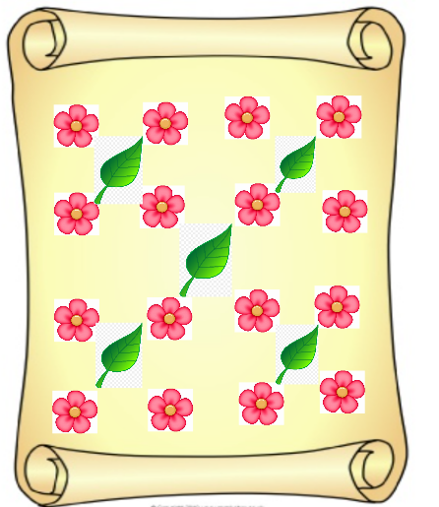

Here is my example!

