Art 5.6
For the next few weeks we will be looking at Chinese art.
Look at the examples of Chinese calligraphy below.
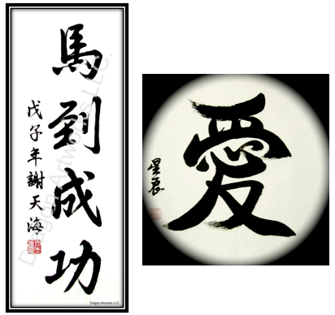

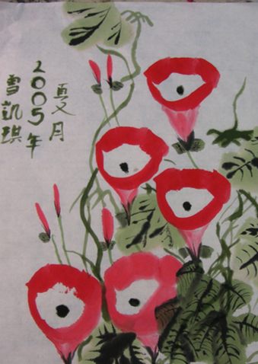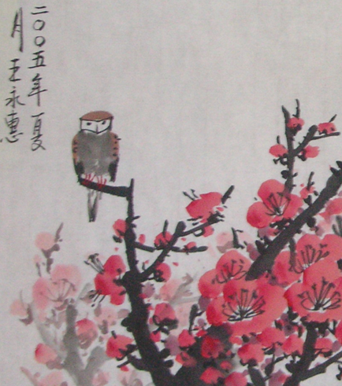

Practice the following Chinese calligraphy brush strokes.
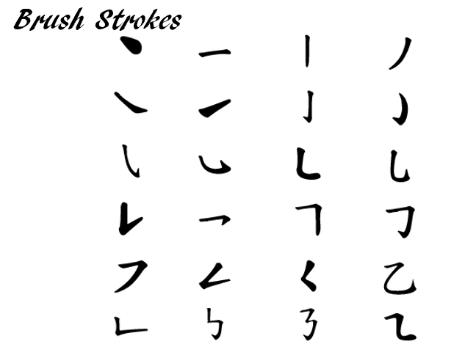

Look at the words below. Can you copy them?

