Art – Henry Rousseau

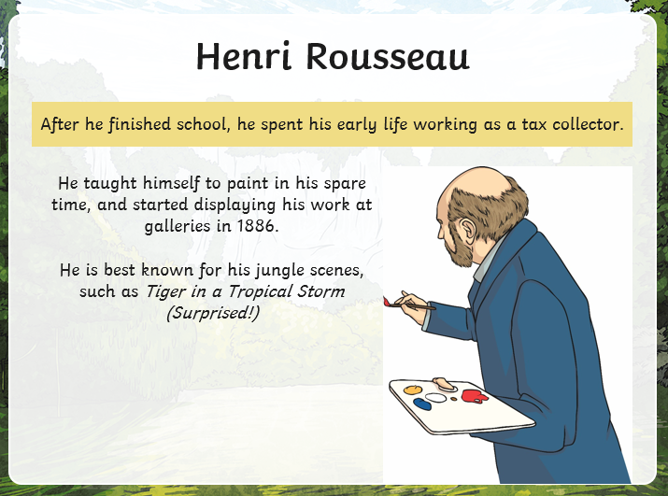

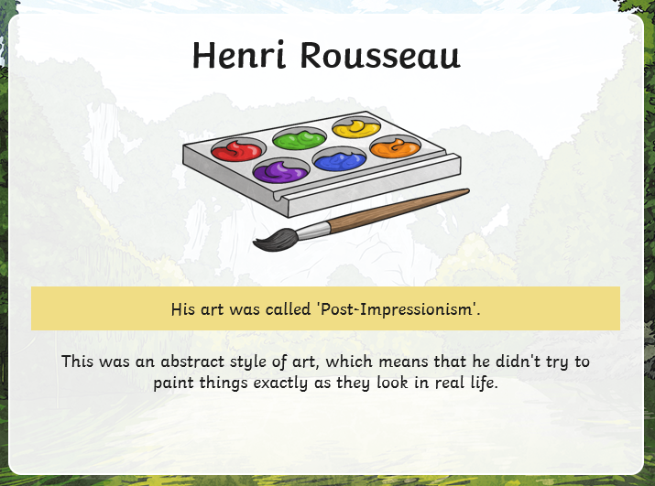

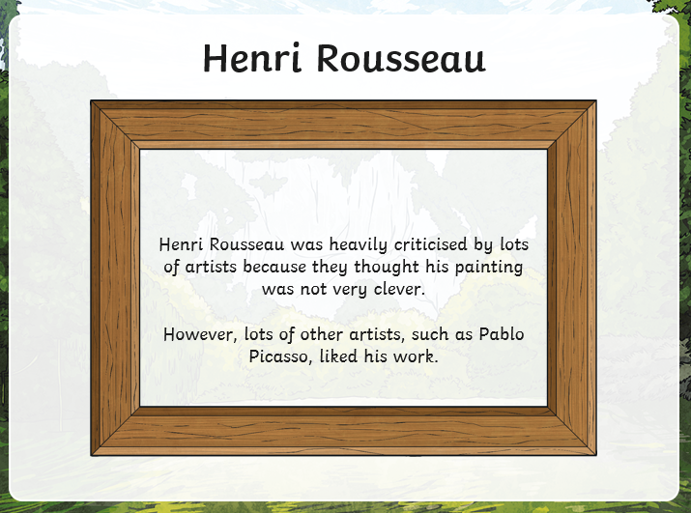

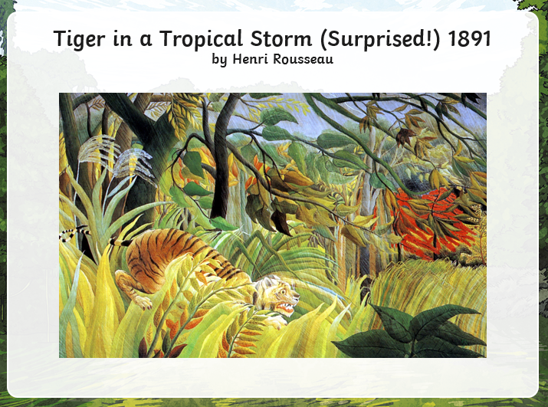

1. How clues tell you that Henry Rousseau painted this picture?
2. What do you like about this painting?
3. What do you dislike about this painting? 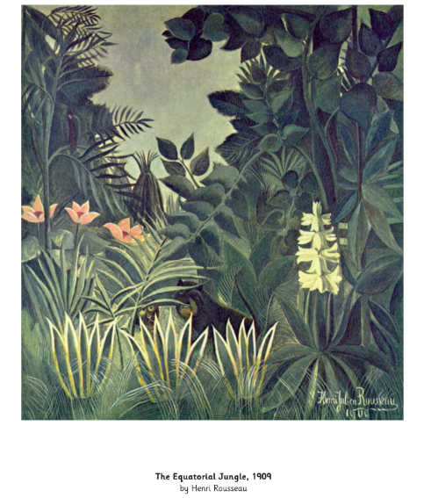

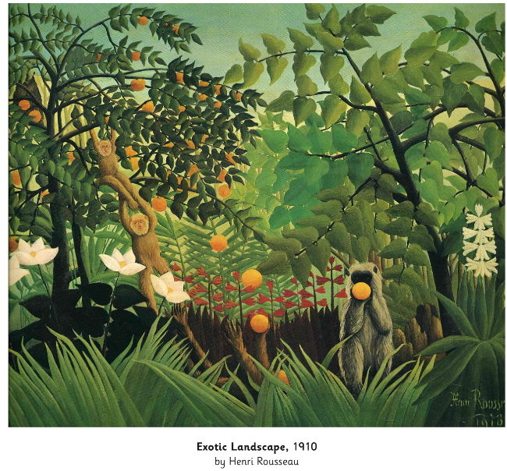

Use one of the above as your inspiration and have a go at creating your own Henry Rousseau inspired picture.