English – Reading Comprehension
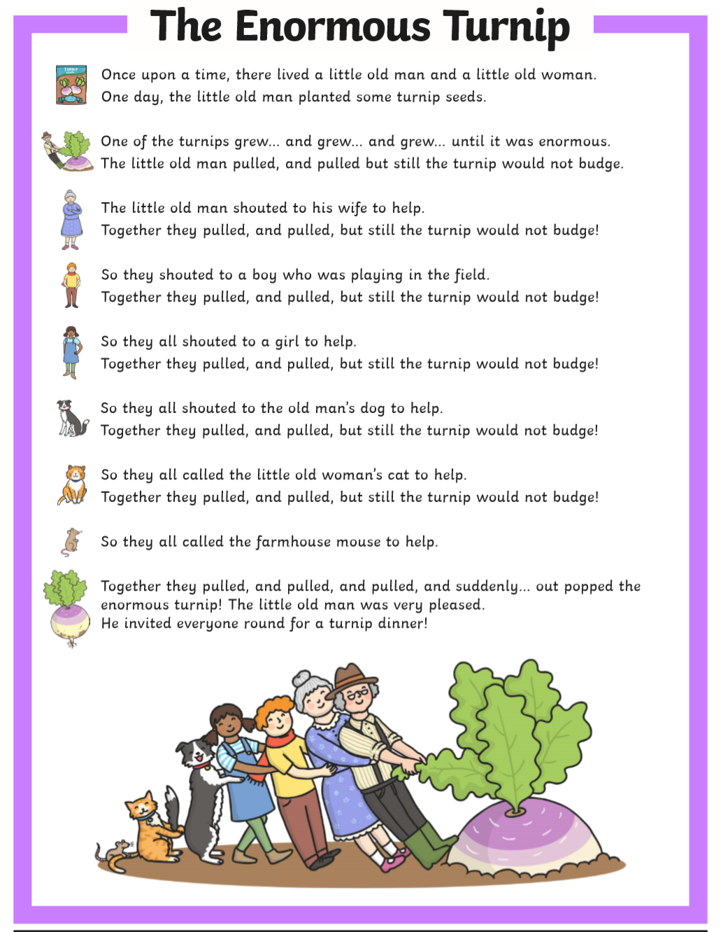
Green
Green Questions:
- Name three characters in the story.
- What vegetable were they trying to pull up?
- Who tried to pull it up on their own?
- Who did the little old man call to help them first?
- Who did they call to help them after the little old woman?
- Where was the boy playing?
- What pet did the little old man have?
- What pet did the little old woman have?
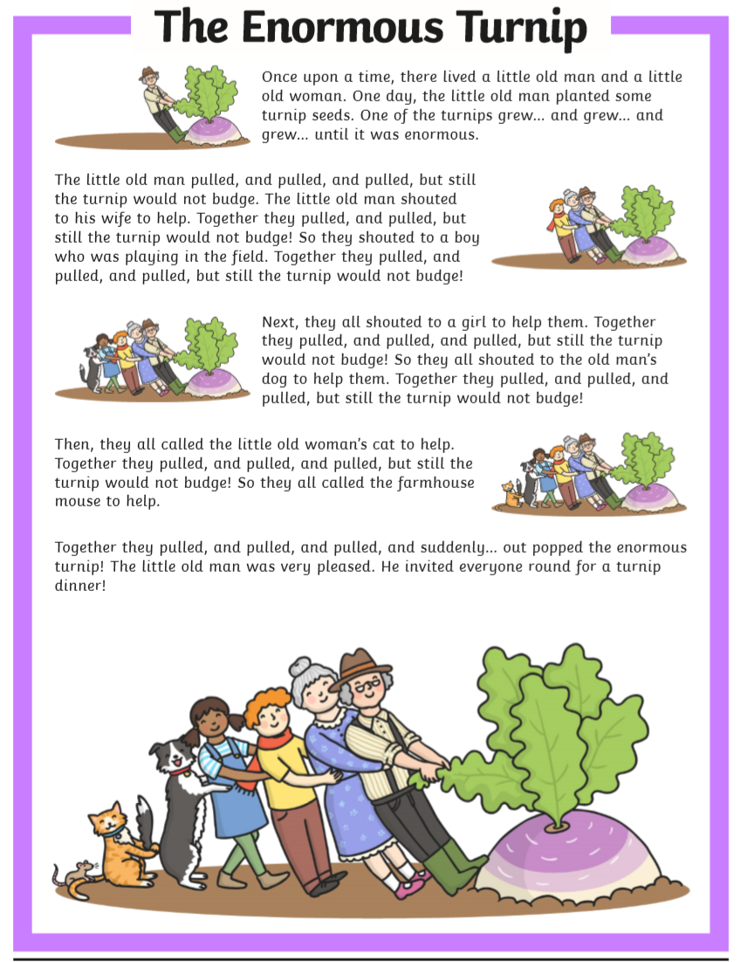
Red

Red Questions:
- Name 5 characters in the story.
- Who did the little old man shout for help first?
- Who did they call to help them after the little old woman?
- Who did they call to help them after the girl?
- What pets did the little old man and woman have?
- Who did they call to help them before the mouse?
- What were they all helping to pull up?
- How many characters did it take to pull it up?
- What did the little old man do to thank everyone at the end?
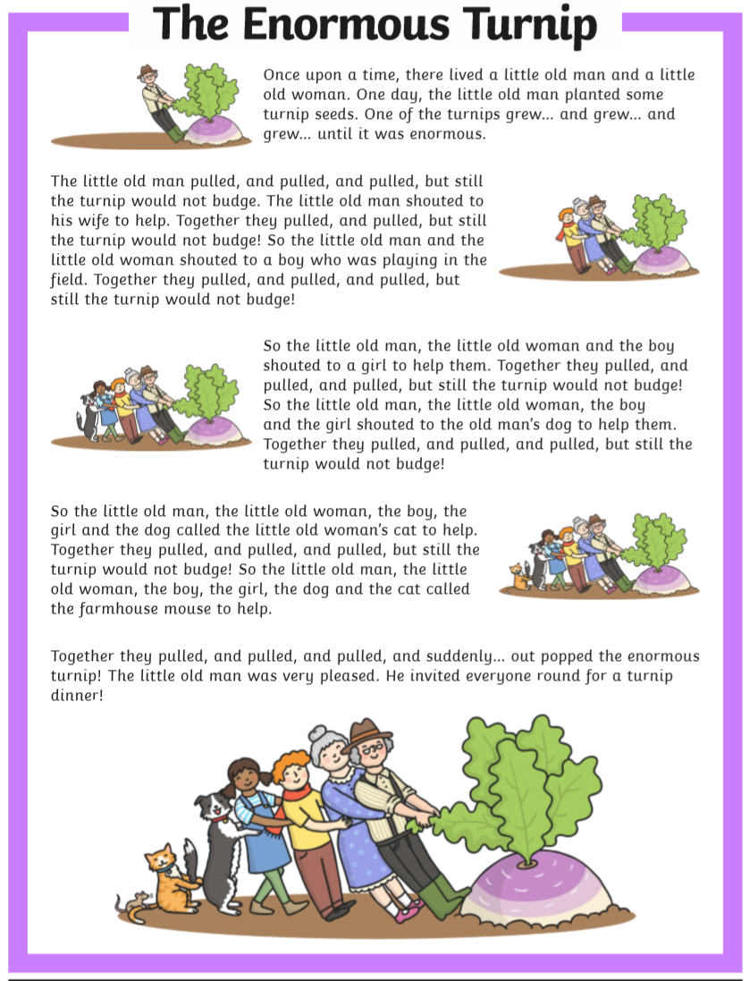
Blue
Blue Questions:
- Name all the characters in the story.
- Who did they call for after the little old woman? Where was this character?
- Who did they call to help them after the boy?
- Which animals lived at the farmhouse?
- Who did they call to help them before the cat?
- Why do you think they wanted to pull up the turnip?
- Why do you think the turnip wouldn’t budge?
- Describe the turnip using 3 adjectives.
- How many characters did it take to pull out the turnip?
- Why do you think the little old ,an invited everyone round for turnip dinner?

