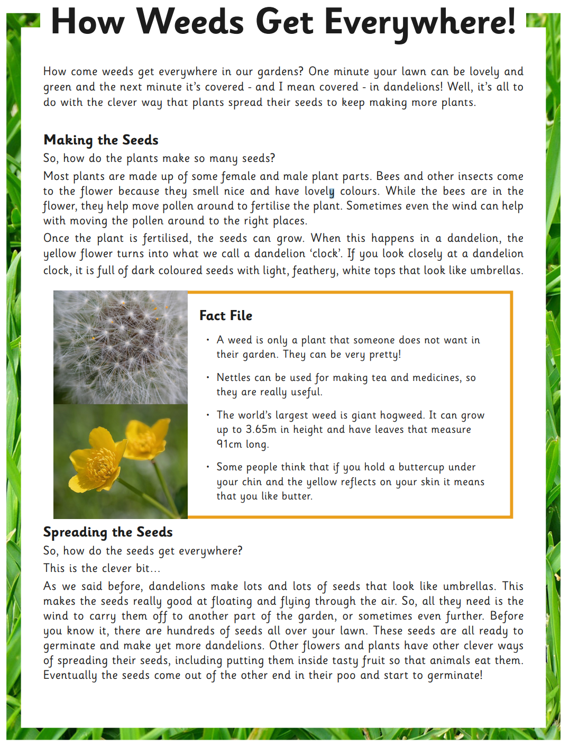
English – Reading Comprehension
Green
- What is the name of the world’s largest weed?
- Which animals can move pollen in the flower?
- What are the dark-coloured objects that you can see in the dandelion clock?
- What is a good thing that nettles can be used for?
- What makes dandelion seeds good at floating in the air?
- What do some people think it means if a buttercup reflects yellow under your chin?
- How tall can the largest weed grow?

Red:
- What is the name of the world’s largest weed?
- Which animals can move pollen in the flower?
- What are the dark-coloured objects that you can see in the dandelion clock?
- What is a good thing that nettles can be used for?
- What makes dandelion seeds good at floating in the air?
- What do some people think it means if a buttercup reflects yellow under your chin?
- How tall can the largest weed grow?
- How many questions are in the text?
- In Paragraph 1, the author used the word ‘it’s.’ Write it in full words without an apostrophe.

Blue
- What is the name of the world’s largest weed?
- Which animals can move pollen in the flower?
- What are the dark-coloured objects that you can see in the dandelion clock?
- What is a good thing that nettles can be used for?
- What makes dandelion seeds good at floating in the air?
- What do some people think it means if a buttercup reflects yellow under your chin?
- How tall can the largest weed grow?
- How many questions are in the text?
- In Paragraph 1, the author used the word ‘it’s.’ Write it in full words without an apostrophe.
- What happens when you blow a dandelion clock and how does it help the dandelion?

