English 3.6
Create a character profile
Watch the following video about Miss Trunchbull.
https://www.bing.com/videos/search?q=matilda+miss+trunchball&&view=detail&mid=B0641A3F027597BF8A5DB0641A3F027597BF8A5D&&FORM=VRDGAR&ru=%2Fvi

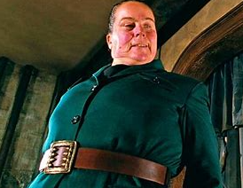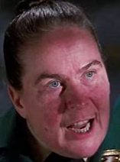

Draw a picture of Miss Trunchbull

Now write a character profile of Miss Trunchbull.
Use the adjective charts below to help you find some interesting adjectives to describe how Miss Trunchbull looks and behaves personality.
Adjectives to describe how Miss Trunchbull looks.

Words to describe how Miss Trunchbull’s personality (how she behaves)

