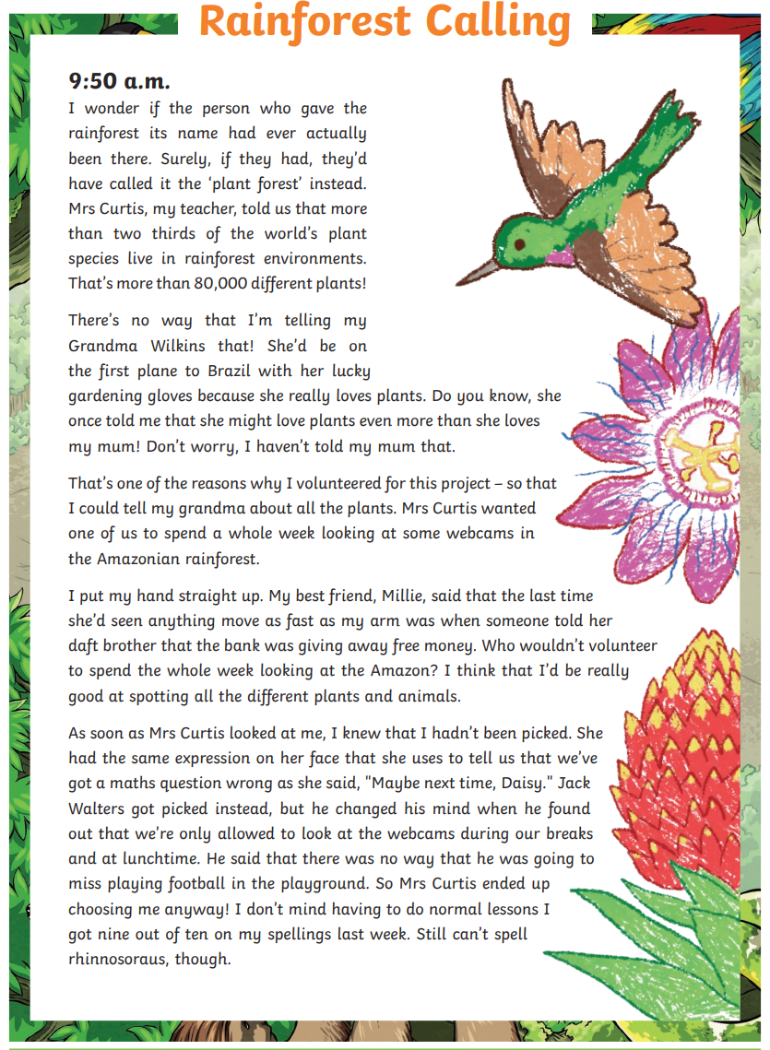
English – Reading Comprehension

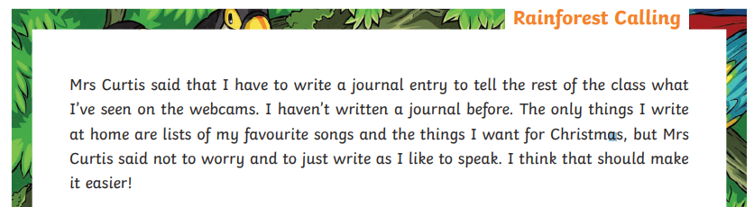
Green/Red:
- What does Daisy suggest the rainforest should be called?

- What portion of the worlds plant species live in the rainforest?
- 80,000
- More than two thirds
- About half
- 1 in 10

- Who is Mrs Curtis?

- Who got picked first instead of Daisy to look at the webcams?

- What does Daisy write in her diary usually?

Blue:
- What does Daisy suggest the rainforest should be called?

- What portion of the worlds plant species live in the rainforest?
- 80,000
- More than two thirds
- About half
- 1 in 10

- Why didn’t Jack take part in the project?

- How do you think Daisy felt about taking part in the project? Use evidence in your answer.

