English - Grammar
Year 3: Identifying Verbs
- Click and watch the following videos on ‘Learn’ - https://www.bbc.co.uk/bitesize/articles/zfc2mfr
- Once you have watched the videos, please complete the activities.
Activity 1 – Online
Activity 2 – This resource is below.
Activity 3 – Complete 5 sentences that describe the gorilla using verbs.
Activity 4 – This below also. On this sheet, you need to add the write verb into the sentences.

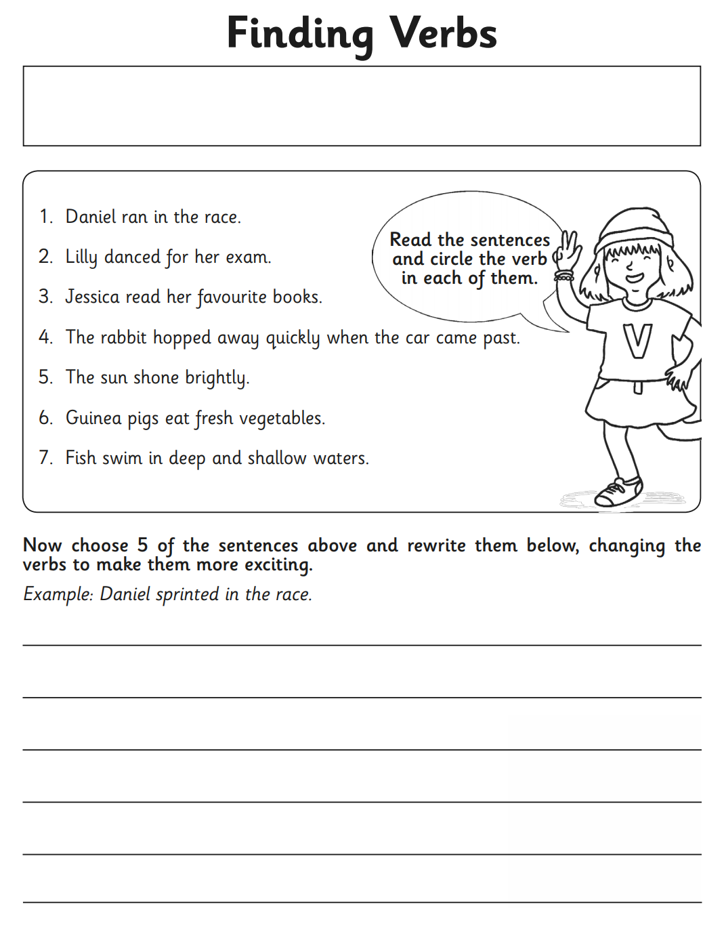
Activity 2:

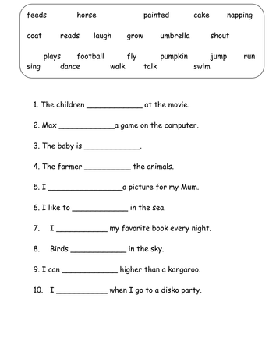
Activity 4:

