English Year 3 and 4
Go to the following web page - https://www.bbc.co.uk/bitesize/articles/z4k6wnb
Watch the 2 videos and try the activities.
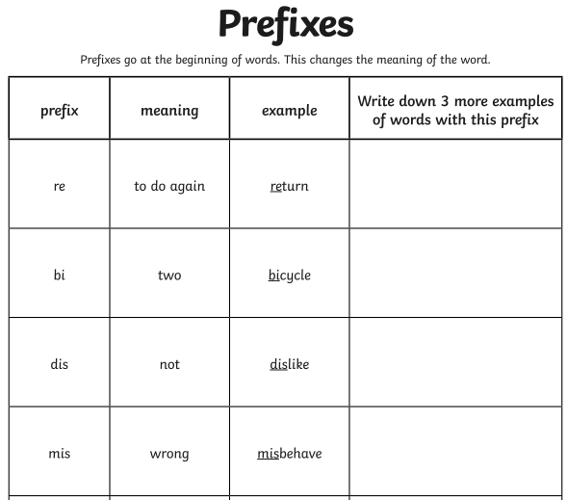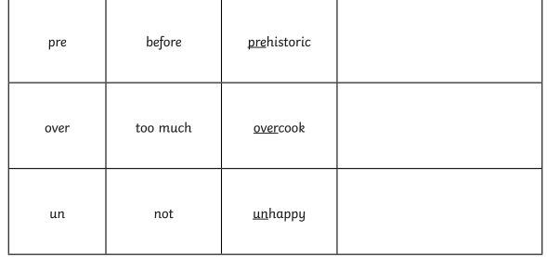

Find the answers below

