English – Grammar
Year 4: Past Tense verbs and verb families:
- Click on the link and watch the videos under ‘Learn.’ - https://www.bbc.co.uk/bitesize/articles/zh4thbk
- Go through ‘Practise’ and complete the activities.

Activity 1 – Online
Activity 2 – Read through the information and then complete the activity which is below.
Activity 3- Read through the information and then complete the activity which is below.
Activity 4 – Complete the sentences by adding in the correct verbs.

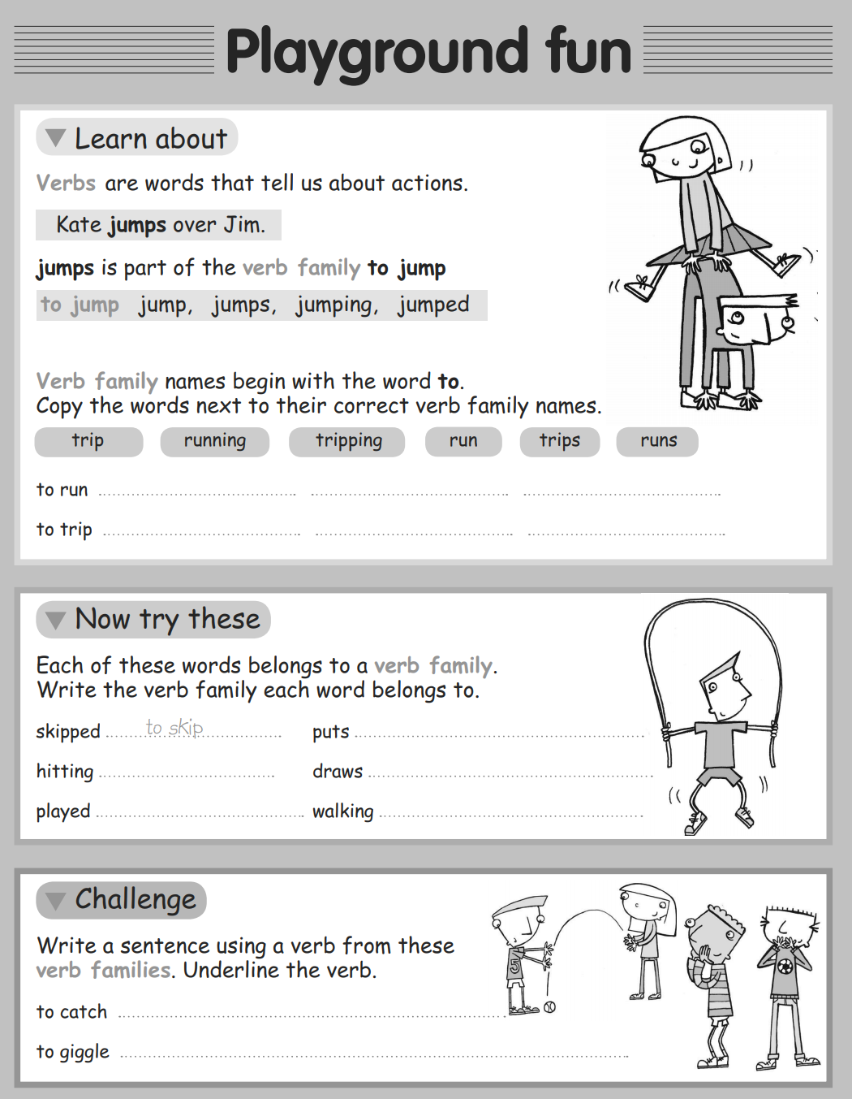
Activity 2:

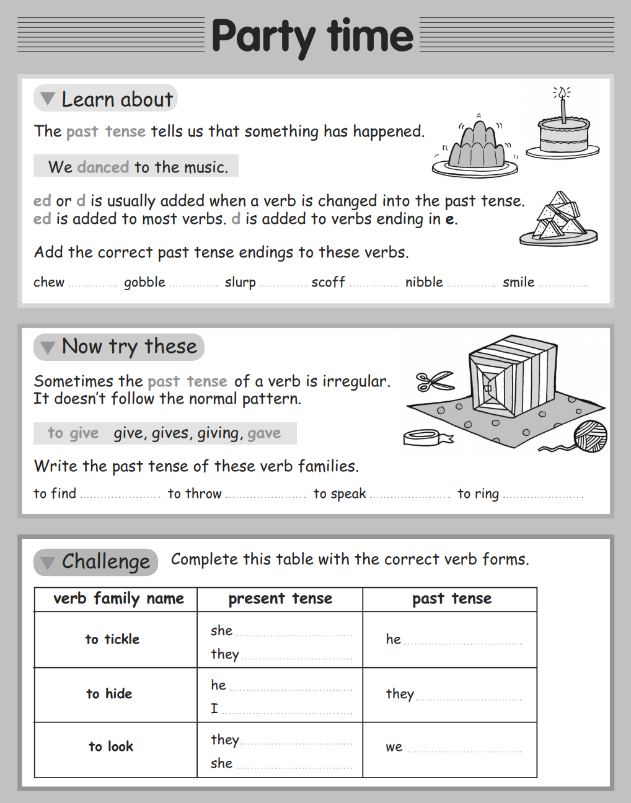
Activity 3:
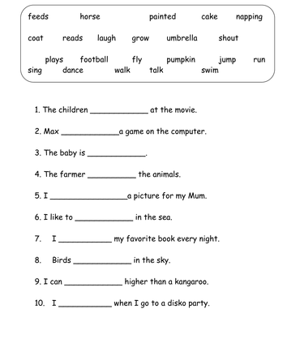
Activity 4:

