English Year 5
Can you decide which is image represents an advert or a brochure?
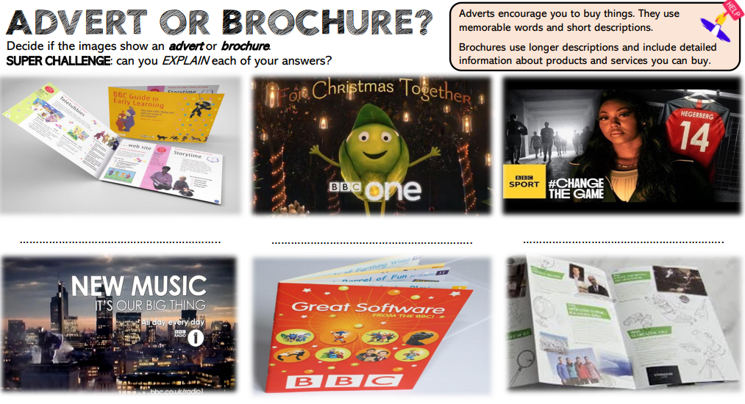
Go to the following web page: https://www.bbc.co.uk/bitesize/articles/zq8m8hv
Watch the videos and try the activities.
Activity – Use the sheet below to help write your own tourist brochure.
